

**P.E. Society’s**

**MODERN COLLEGE OF**

**ARTS, SCIENCE & COMMERCE.**

**(Business Administration Campus),**

**SHIVAJI NAGAR, PUNE 411005.**

**CERTIFICATE**

**Name1: -Aniket Pandurang Digge**

**Name2: -Ronit Sanjay Kohinkar**

**Class: TYBBA(CA)**

**ERNO:-7919**

**ERNO:-8556**

**Div: A**

Have satisfactorily completed the project, entitled

**Chit Fund Management System**

For the Project Management course towards partial fulfilment of B.B.A(C.A) (Sem-V) course of Savitribai Phule Pune University For the academic year 2020-2021 as a part of curriculum.

Date: -

College Stamp Project Guide

Prof: Vaibhav Thakre

Internal Examiner External Examiner

**ACKNOWLEDGEMENTS**

We have a great pleasure to present this project on-

**Chit-Fund Management System**

We have thankful to P. E. Society’s Modern College of Arts, Science & Commerce, Shivajinagar, Pune-41005. For giving us the opportunity to carry out B.B.A.-CA (Sem-V) Project at their concern.

Many people have contribution in this project report, we are grateful to Prof M.D.Alandikar, the Vice-Principal for his co-operation. Our special thanks to Prof. Vaibhav Thakre for his constructive suggestions and comments and for lending his expertise and talent when needed. And above all, we thank the Almighty for his grace and blessings.

Finally, we would like to thank each and every one who was directly or Indirectly involved with this project report.

**INDEX**

1. **Introduction**

* Company Profile
* Introduction to system
* Scope of the system
* Proposed System

1. **Analysis**

* Fact Finding Technique
* Feasibility Study
* Hardware & Software Requirement

1. **System Design**

* E-R Diagram
* Context Level Diagram
* Data Flow Diagram
* File Design
* Data Dictionary

1. **Form Design (with input values)**
2. **Reports**
3. **Advantages & Limitations**
4. **Future Enhancement**
5. **Bibliography**

**1.INTRODUCTION**

**1). INTRODUCTION POINTS**

● Introduction to System

● Scope of the System

●Proposed System

**Introduction to System: -**

The objective of this project is to computerize the existing system to gain accuracy, reduce paperwork, data integrity and better error handling and to make it more convenient for the user to optimize and use the software at full potential at one place. In this system we have used Microsoft Visual Studio 2019 as frontend and Microsoft Access as backend for the database.

* The Client would be able to manage several Members at a time.
* Data Redundancy is reduced so that there would be no duplication of data.
* Through this Software the user can maintain Records of several Members without loss of space or data.
* It is also Cost Effective & does not consume Extra Time.
* In this system we would be implementing the technique to generate soft copy of the Report, in short Report generation.

**SCOPE OF THE SYSTEM: -**

The project is basically meant to computerize the existing system for order and bill generation, so as to gain accuracy, processing speed, data consistency, integrity, better error handling, etc.

• To provide a proper registration channel/system to the new users.

• To maintain all records of employee, members in a digital form.

• To make the information available to admin and employee, in just few click.

• To have a centralized control over the records of staff, members and monitor changes in these records

• This system is to simplify complicated process of maintain and updating.

**Proposed System: -**

The proposed system is computerized one, in which time is greatly reduced. Since this is a computerized one there will be no chances of human error to encounter. In the proposed system there will be a lot of improvement in the quality, speed and efficiency. This system is all in one because in proposed system company can maintain employee’s data as well. Since it is user friendly any one can operate individually. Also, it does not contain Paper usage as compared to Existing System. Also, its Easy to Maintain records for any emergency use-age in our System it’s also useful for creating Reports of Employees & Consumers. It is useful for Bill Generation Since the user/Admin can generate Billing Report also one can Enter an new Record directly in the Database. This proposed System is a good solution for Data storage issue since most of its Data would be Saved in the Access Database which means from one particular place it would be stored and accessed.

**Objectives: -**

* Make the system user friendly & Interactable, Convenient.
* Record Management.
* To generate Reports.
* To reduce Time-Consumption issue.
* To generate Bill Report.
* Add/Update/Delete Members & Employees.

**2.ANALYSIS**

**2). Analysis points**

●Fact Finding Technique.

●Feasibility Study.

●Hardware & Software Requirements

**a).Fact finding technique:-**

Fact-finding is an important activity in system investigation; any system is depending upon data and all its relevant information. The facts when expressed in quantitative form are termed as data. A kind part of feasibility analysis is gathering information about the present system.

These include the record review and observation. The analyst must know what information to gather, to make of it. The proper use of tools for gathering information is the key to success analysis.

We have used two fact finding techniques in our system analysis.

● Record Reviews.

● Observation

**1) Record Searching: -**

This technique helped me to know that how do they store data in their file? Which transactions affect which types of files? What type of updates they perform? Study of already available documents is the fastest and independent way of gathering fact and information based on which further processes can be welled structured.

**2) Observations: -**

This technique helped me to know the actual flow of the documents; the persons involved in the procedures, what steps they follow. I also came to know about the pros and cons of their manual system.

**b). Feasibility Study: -**

The aims of a Feasibility study are to find out whether the system is worth implementing and if it can be implemented, given the existing budgets and schedule. The input to the feasibility study is a set of preliminary requirements, an outline description of the system and how the system is intended to support business processes.

As a part of preliminary investigation the feasibility study was carried out. The proposed system was viewed from three aspects.

1. **Social Feasibility: -**

Although generally there is always resistance, initially to any change in the system, the system is aimed at relieving the work load of the end users. The system has been developed keeping the customer, their work culture and their previous habits in their mind.

The system is going to help the end users to perform the maintenance of the records and report generation with the least possible errors. Moreover, the system is very user friendly. Thus, there is no reason for the project to be socially unfeasible.

1. **Operational Feasibility: -**

Proposed system has been developed keeping the point of view of existing employees. The **“CHIT-FUND** **MANAGEMENT SYSTEM”** already has the staff with the required technical knowledge to operate the system. So, the need to recruit, select and train new employees to operate the system is not really felt.

The system being highly graphically interactive, the need of highly trained technical staff is not required. Thus, the system is operationally feasible.

1. **Technical Feasibility: -**

The proposed system will be built using Microsoft Visual Studio 2019 as frontend and Microsoft Access version 16.0 as backend. Thus, new system will not be cost bearing for the organization.

1. **Economic Feasibility: -**

Keeping in view all the other parts of feasibility, it automatically reflects the system also seems to be economically feasible. It will reduce the organization’s hardware and software expenses to some extent.

**c).Hardware & Software Requirement: -**

**HARDWARE REQUIREMENTS:**

* **Processor: -** Dual Core Processor and Above
* **RAM: -** 4 GB
* **Hard Disk: -** 40 GB
* **External Device**: - Printer

**SOFTWARE REQUIREMENT:**

● **Front-end: -** Visual Studio 2019 [C#.NET]. **Version: -**16.8.

● **Back-end: -** MS Access Database **Version: -**16.0.

● **Operating System: -** Windows 7 & Above.

**3.System Design**

**3). System Design Points**

* + - * ER Diagram
      * Context Level Diagram
      * Data Flow Diagram
      * File Design
      * Data dictionary

**Entity Relation Diagram: -**

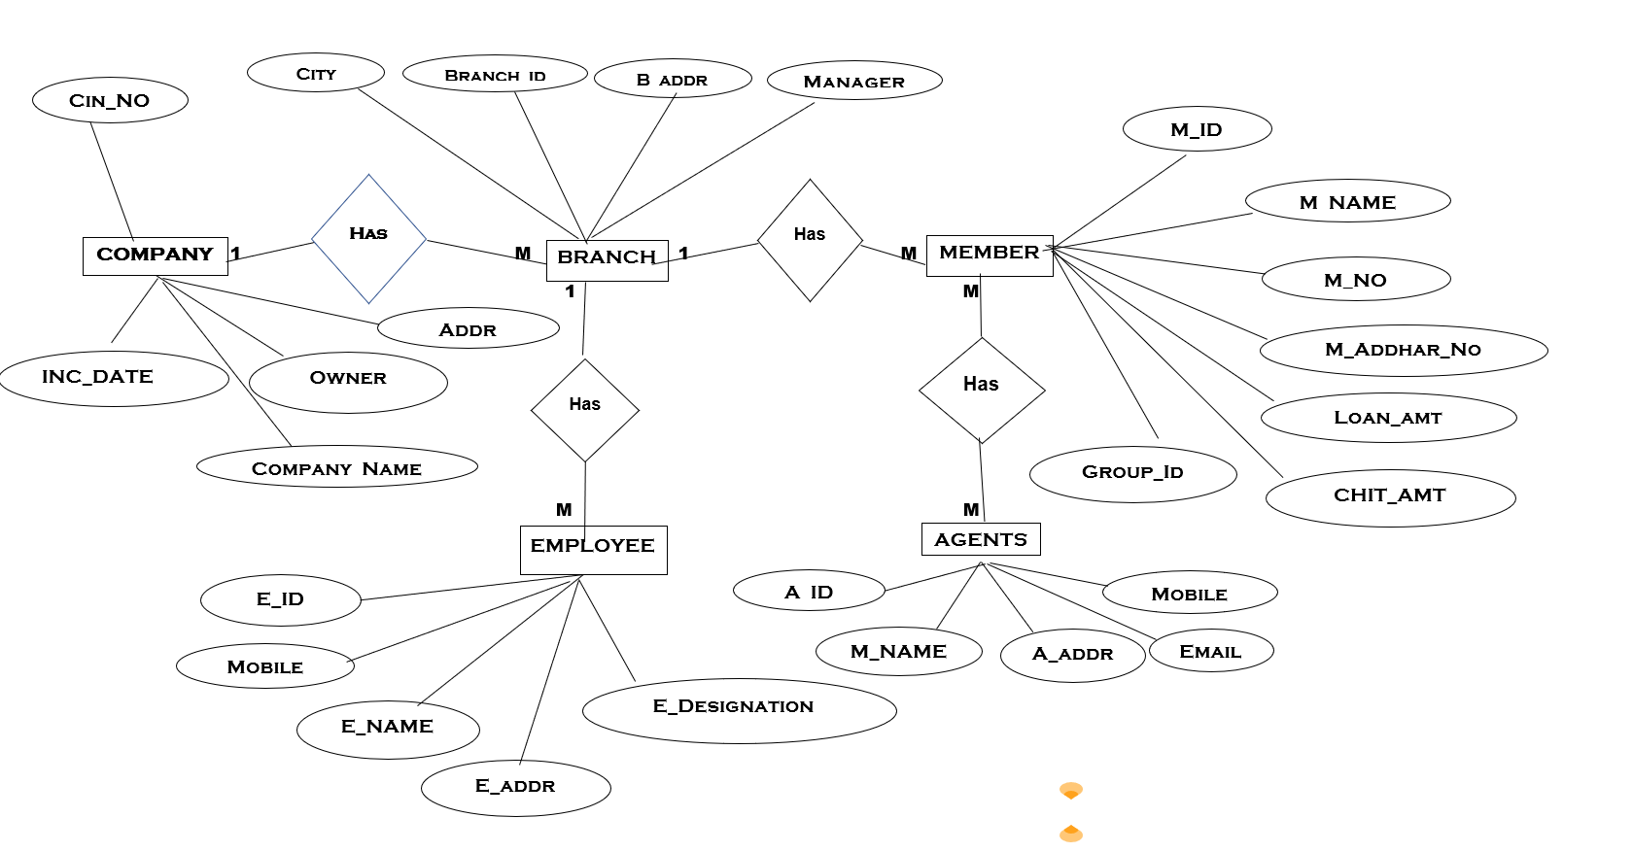

**Context Level DFD: -**

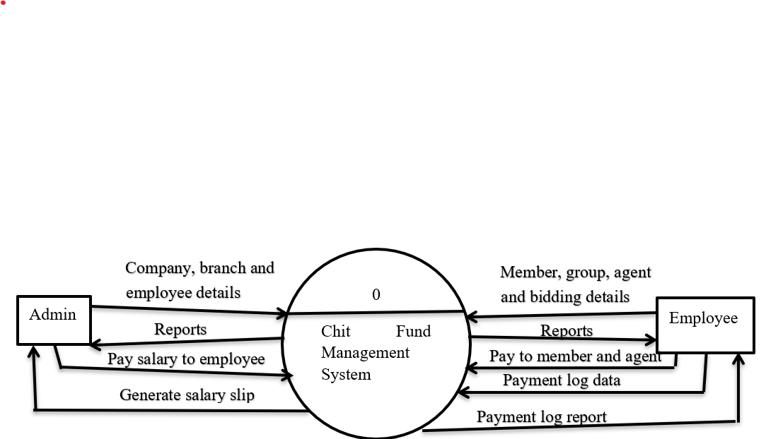

**Data Flow Diagram [level 1]: -**

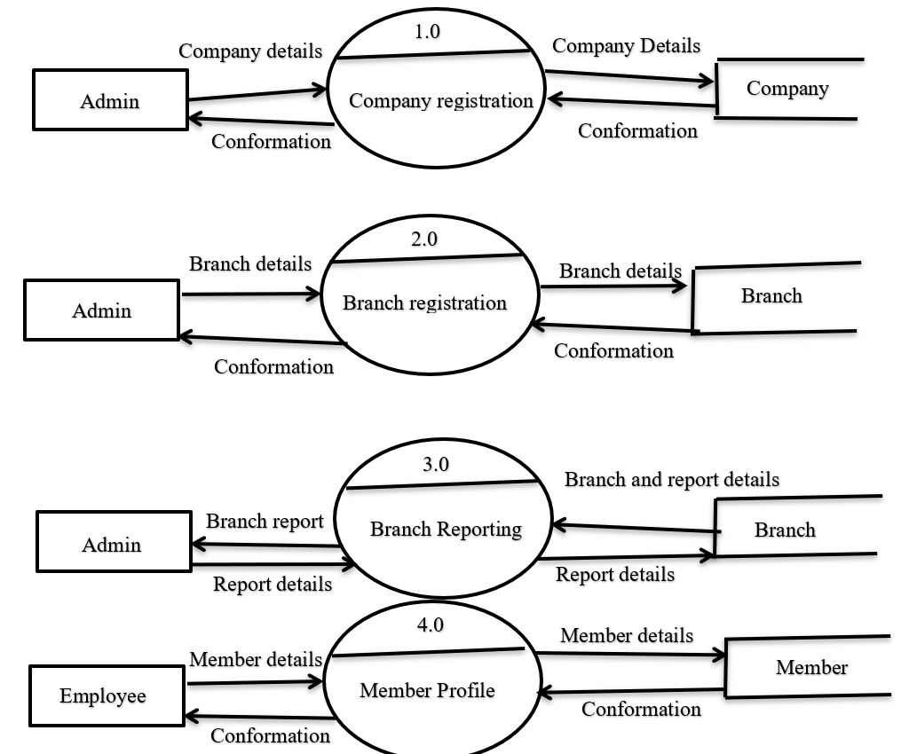

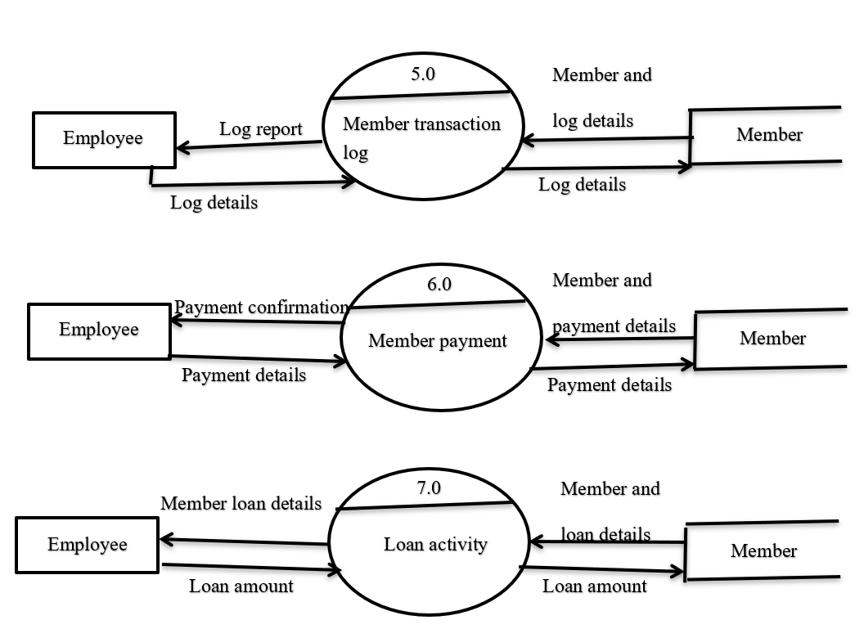

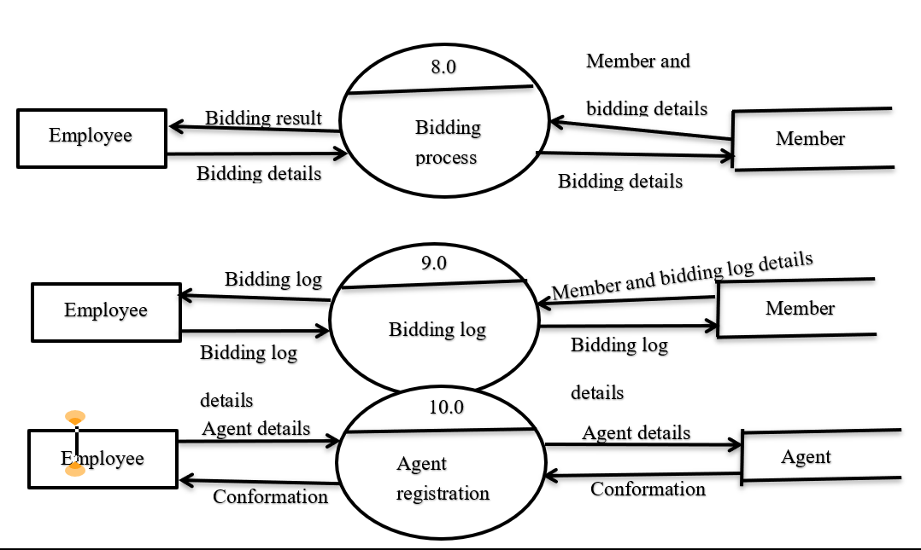

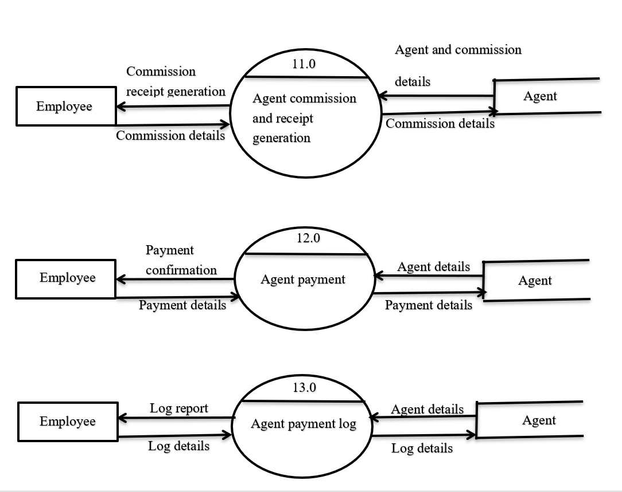

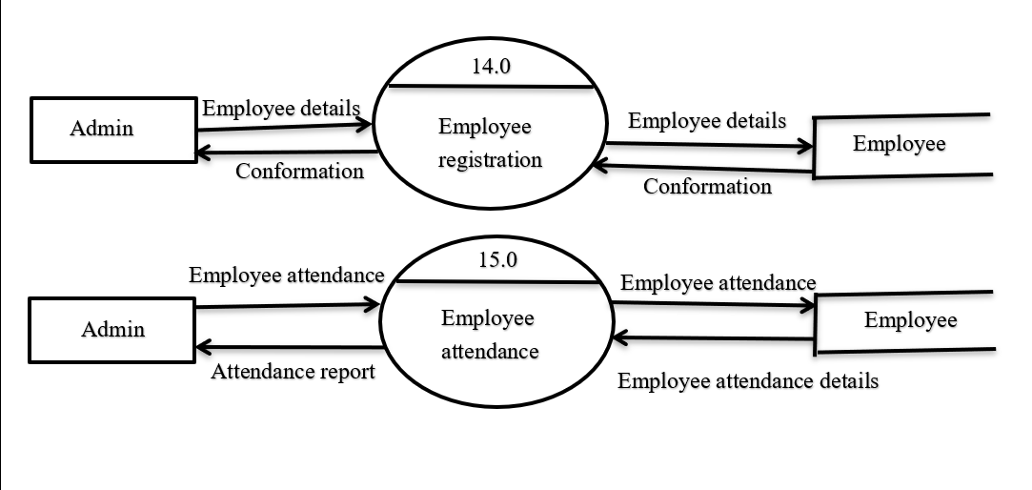

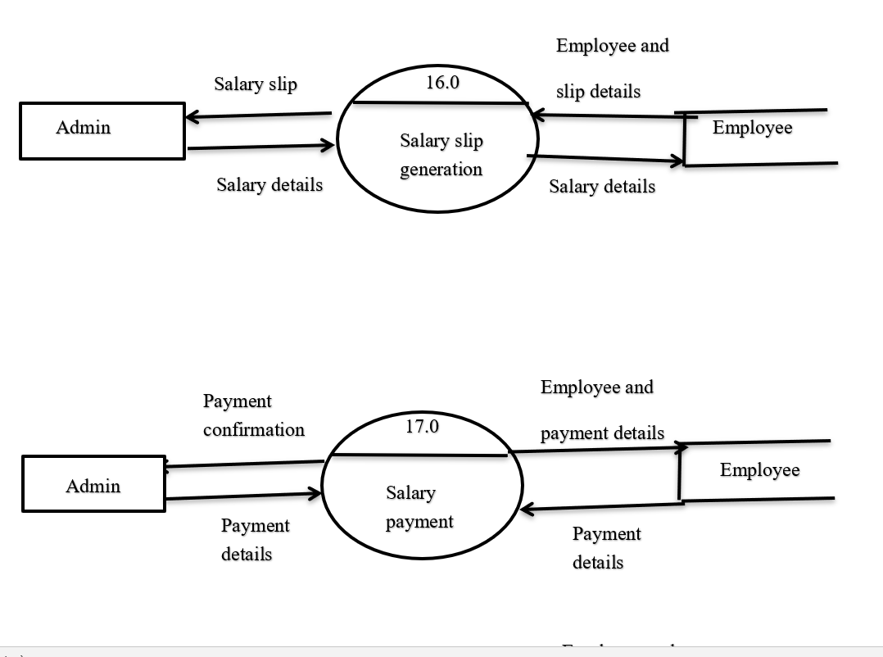

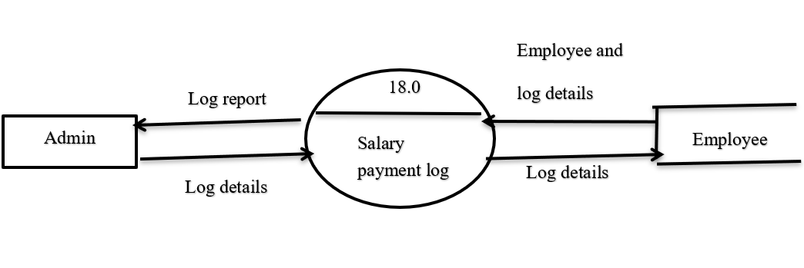

**File Design:-**

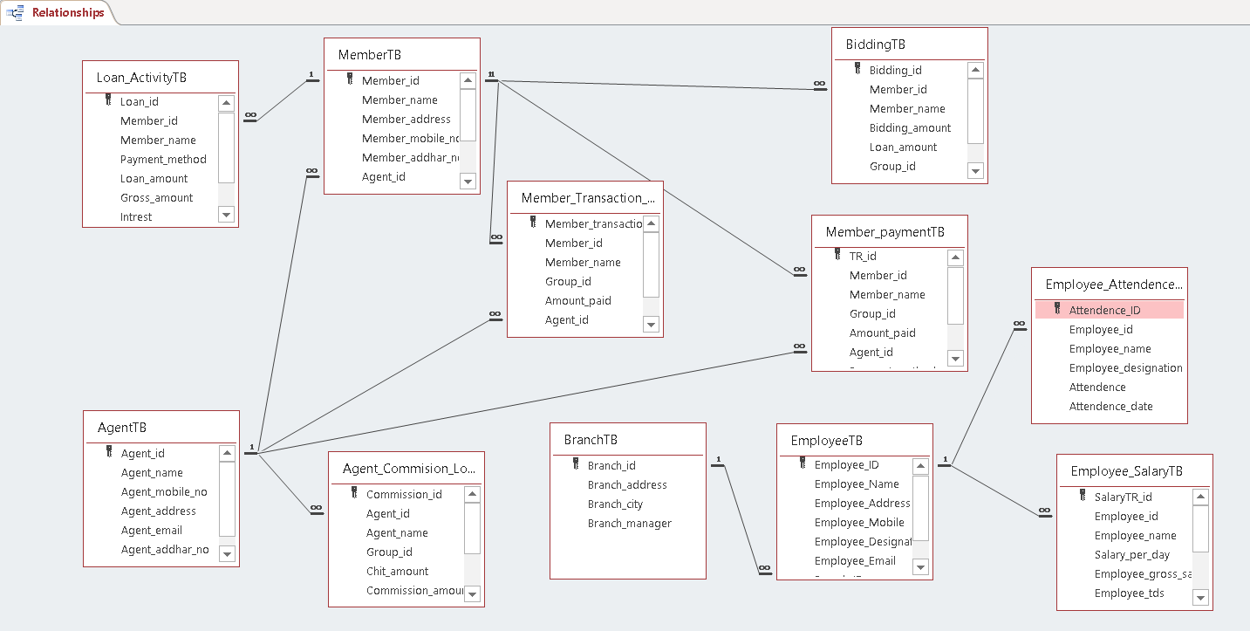

**Data Dictionary:-**

**Login:**

|  |  |  |  |
| --- | --- | --- | --- |
| **Field Name** | **Data Type** | **Constraints** | **Description** |
| User_id | Number | Primer Key | User ID |
| User_name | Short Text | Not Null | User Name |
| Password | Short Text | Not Null | Password |
| User_type | Short Text | Not Null | User Type |

**Member:**

|  |  |  |  |
| --- | --- | --- | --- |
| **Field Name** | **Data Type** | **Constraints** | **Description** |
| Member_id | Number | Primer Key | Member ID |
| Member_name | Short Text | Not Null | Member Name |
| Member_address | Long Text | Not Null | Member Address |
| Member_mobile_no | Short Text | Not Null | Member Mobile Number |
| Member_addhar_no | Short Text | Not Null | Member Addhar Number |
| Agent_id | Number | Foreign Key | Agent ID |
| Chit_amount | Currency | Not Null | Chit Amount |
| Loan_amount | Currency | Not Null | Loan Amount |
| Group_id | Number | Null(single member) | Group ID |
| Member_entry_date | Date/Time | Not Null | Member Entry Date |

**Member Transaction Log:**

|  |  |  |  |
| --- | --- | --- | --- |
| **Field Name** | **Data Type** | **Constraints** | **Description** |
| Member_transaction_log_id | AutoNumber | Primer Key | Member Transaction Log ID |
| Member_id | Number | Foreign Key | Member ID |
| Member_name | Short Text | Not Null | Member Name |
| Group_id | Number | Null(single member) | Group ID |
| Amount_paid | Currency | Not Null | Amount Paid |
| Agent_id | Number | Foreign Key | Agent ID |
| Transaction_method | Short Text | Not Null | Transaction Method |
| Transaction_date | Date/Time | Not Null | Transaction Date |

**Member Payment:**

|  |  |  |  |
| --- | --- | --- | --- |
| **Field Name** | **Data Type** | **Constraints** | **Description** |
| TR_id | AutoNumber | Primer Key | Transaction ID |
| Member_id | Number | Foreign Key | Member ID |
| Member_name | Short Text | Not Null | Member Name |
| Group_id | Number | Null(single member) | Group ID |
| Amount_paid | Currency | Not Null | Amount Paid |
| Agent_id | Number | Foreign Key | Agent ID |
| Payment_method | Short Text | Not Null | Payment Method |
| Payment_type | Short Text | Not Null | Payment Type |
| Transaction_date | Date/Time | Not Null | Transaction Date |

**Loan Activity:**

|  |  |  |  |
| --- | --- | --- | --- |
| **Field Name** | **Data Type** | **Constraints** | **Description** |
| Loan_id | AutoNumber | Primer Key | Loan ID |
| Member_id | Number | Foreign Key | Member ID |
| Member_name | Short Text | Not Null | Member Name |
| Payment_method | Short Text | Not Null | Payment Method |
| Loan_amount | Currency | Not Null | Loan Amount |
| Gross_amount | Currency | Not Null | Gross Amount |
| Intrest | Currency | Not Null | Intrest |
| Total_amount | Currency | Not Null | Total Amount |
| Installment_date | Date/Time | Not Null | Installment Date |

**Company:**

|  |  |  |  |
| --- | --- | --- | --- |
| **Field Name** | **Data Type** | **Constraints** | **Description** |
| CIN_no | Number | Primer Key | Company Registration Number |
| Company_name | Short Text | Not Null | Company Name |
| Address | Long Text | Not Null | Company Address |
| City | Short Text | Not Null | Company City |
| Owner | Short Text | Not Null | Company Owner |
| No_of_branches | Number | Not Null | No Of Branches |

**Branch:**

|  |  |  |  |
| --- | --- | --- | --- |
| **Field Name** | **Data Type** | **Constraints** | **Description** |
| Branch_id | Number | Primer Key | Branch ID |
| Branch_address | Long Text | Not Null | Branch Address |
| Branch_city | Short Text | Not Null | Branch City |
| Branch_manager | Short Text | Not Null | Branch Manager |

**Bidding:**

|  |  |  |  |
| --- | --- | --- | --- |
| **Field Name** | **Data Type** | **Constraints** | **Description** |
| Bidding_id | AutoNumber | Primer Key | Bidding ID |
| Member_id | Number | Foreign Key | Member ID |
| Member_name | Short Text | Not Null | Member Name |
| Bidding_amount | Currency | Not Null | Bidding Amount |
| Loan_amount | Currency | Not Null | Loan Amount |
| Group_id | Number | Null(single member) | Group ID |
| Chit_amount | Currency | Not Null | Chit Amount |
| Bidding_date | Date/Time | Not Null | Bidding Date |

**Agent:**

|  |  |  |  |
| --- | --- | --- | --- |
| **Field Name** | **Data Type** | **Constraints** | **Description** |
| Agent_id | Number | Primer Key | Agent ID |
| Agent_name | Short Text | Not Null | Agent Name |
| Agent_mobile_no | Short Text | Not Null | Agent Mobile Number |
| Agent_address | Long Text | Not Null | Agent Address |
| Agent_email | Short Text | Not Null | Agent Email |
| Agent_addhar_no | Short Text | Not Null | Agent Addhar Number |
| Agent_joining_date | Date/Time | Not Null | Agent Joining Date |

**Agent Commission Log :**

|  |  |  |  |
| --- | --- | --- | --- |
| **Field Name** | **Data Type** | **Constraints** | **Description** |
| Commission_id | AutoNumber | Primer Key | Commission ID |
| Agent_id | Number | Foreign Key | Agent ID |
| Agent_name | Short Text | Not Null | Agent Name |
| Group_id | Number | Null(single member) | Group ID |
| Chit_amount | Currency | Not Null | Chit Amount |
| Commission_amount | Currency | Not Null | Commission Amount |
| Commission_tax | Currency | Not Null | Tax On Commission |
| Net_commission | Currency | Not Null | Net Commission |
| Payment_menthod | Short Text | Not Null | Payment Method |
| Date_of_received | Date/Time | Not Null | Received Date |

**Employee:**

|  |  |  |  |
| --- | --- | --- | --- |
| **Field Name** | **Data Type** | **Constraints** | **Description** |
| Employee_ID | Number | Primer Key | Employee ID |
| Employee_Name | Short Text | Not Null | Employee Name |
| Employee_Address | Long Text | Not Null | Employee Address |
| Employee_Mobile | Short Text | Not Null | Employee Mobile |
| Employee_Designation | Short Text | Not Null | Employee Designation |
| Employee_Email | Short Text | Not Null | Employee Email |
| Branch_ID | Number | Foreign Key | Branch ID |
| Date_of_Joining | Date/Time | Not Null | Date Of Joining |

**Employee Salary:**

|  |  |  |  |
| --- | --- | --- | --- |
| **Field Name** | **Data Type** | **Constraints** | **Description** |
| SalaryTR_id | AutoNumber | Primer Key | Transaction ID |
| Employee_id | Number | Foreign Key | Employee ID |
| Employee_name | Short Text | Not Null | Employee Name |
| Salary_per_day | Currency | Not Null | Salary Per Day |
| Employee_gross_salary | Currency | Not Null | Gross Salary |
| Employee_tds | Currency | Not Null | TDS On Salary |
| Employee_pf | Currency | Not Null | PF On Salary |
| Employee_net_salary | Currency | Not Null | Net Salary |
| Payment_method | Short Text | Not Null | Payment Method |
| Date_of_slip | Short Text | Not Null | Slip Date |
| Employee_designation | Short Text | Not Null | Employee Designation |

**Employee Attendance:**

|  |  |  |  |
| --- | --- | --- | --- |
| **Field Name** | **Data Type** | **Constraints** | **Description** |
| Attendence_ID | AutoNumber | Primer Key | Attendance ID |
| Employee_id | Number | Not Null | Employee ID |
| Employee_name | Short Text | Not Null | Employee Name |
| Employee_designation | Short Text | Not Null | Employee Designation |
| Attendence | Short Text | Not Null | Attendance P/A |
| Attendence_date | Date/Time | Not Null | Attendance Date |

**4.Form Design**

**(With Input Value)**

1. **Login Form:**

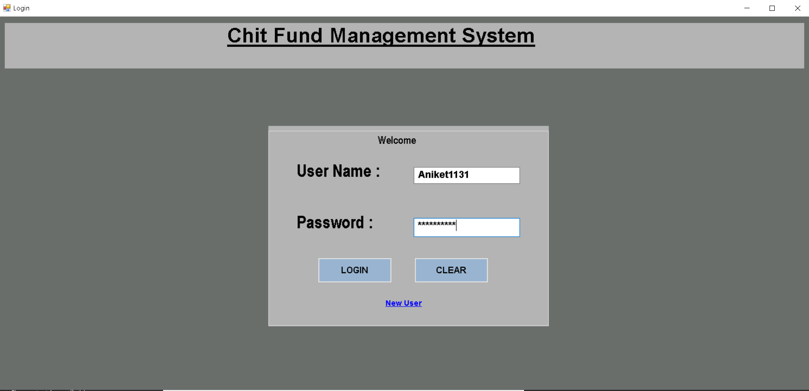

1. **Dash Board:**

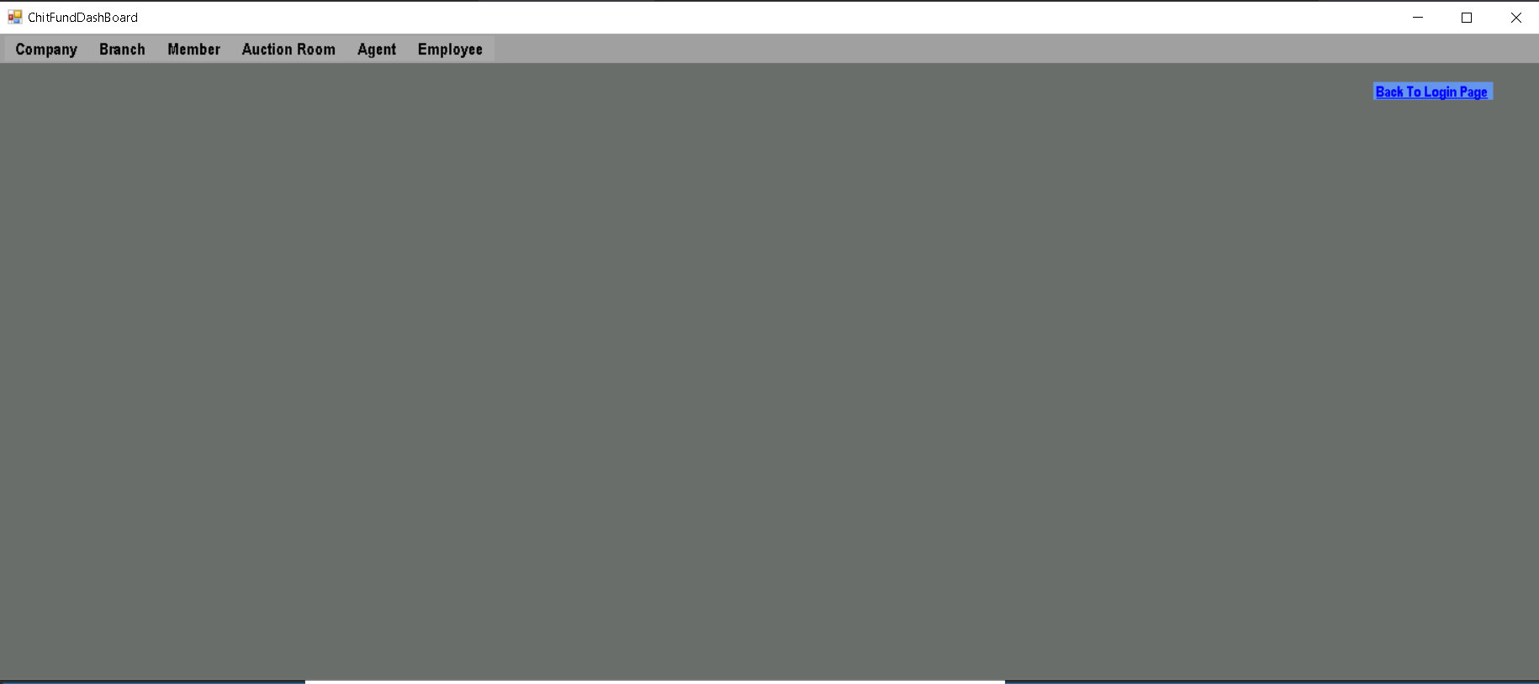

1. **Company Profile:**

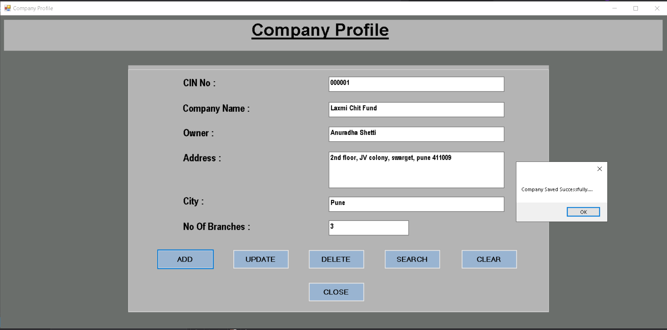

1. **Branch Profile:**

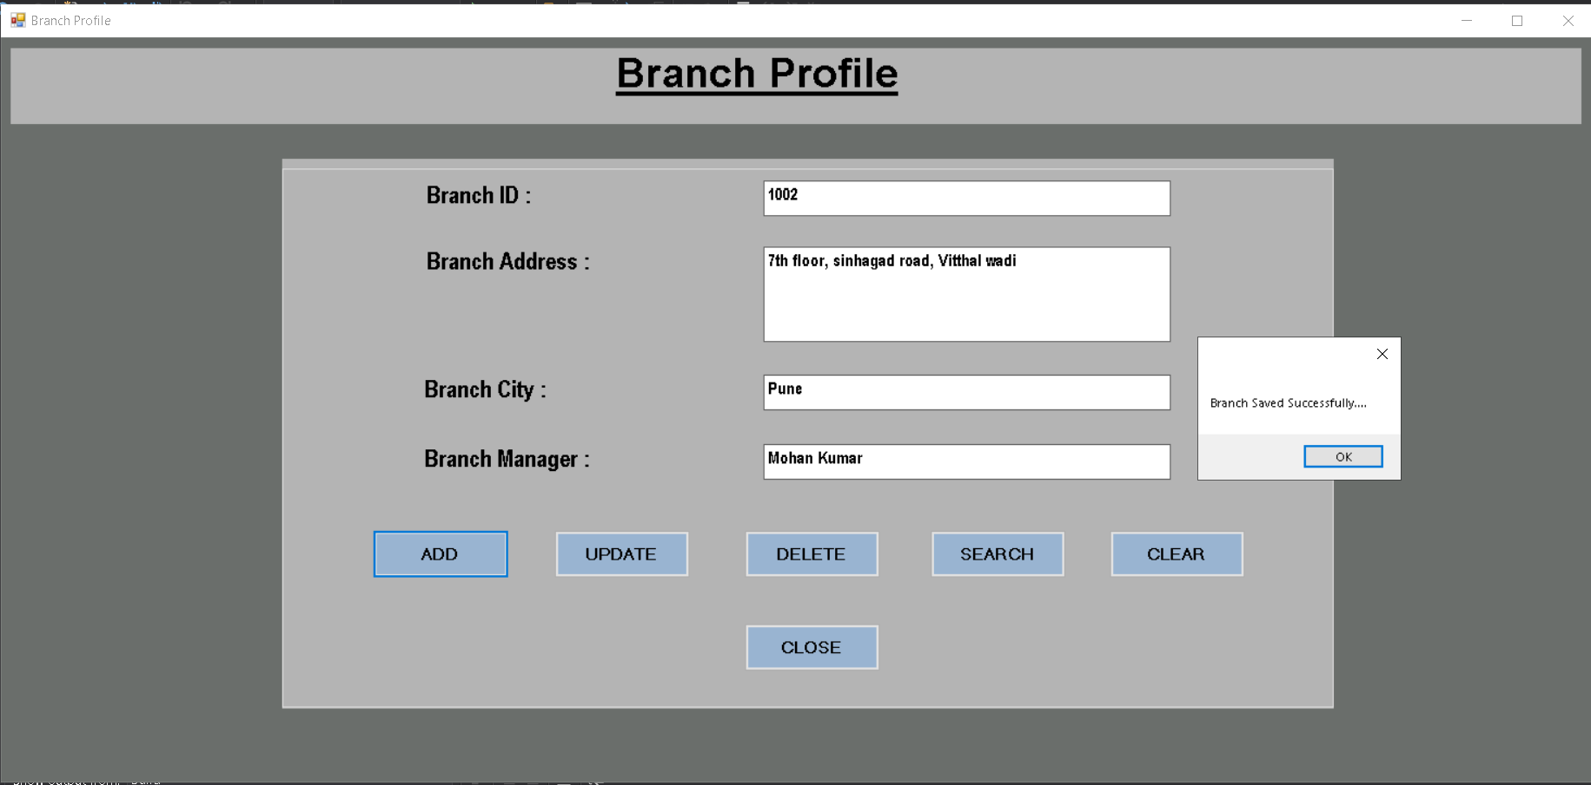

1. **Member Profile:**

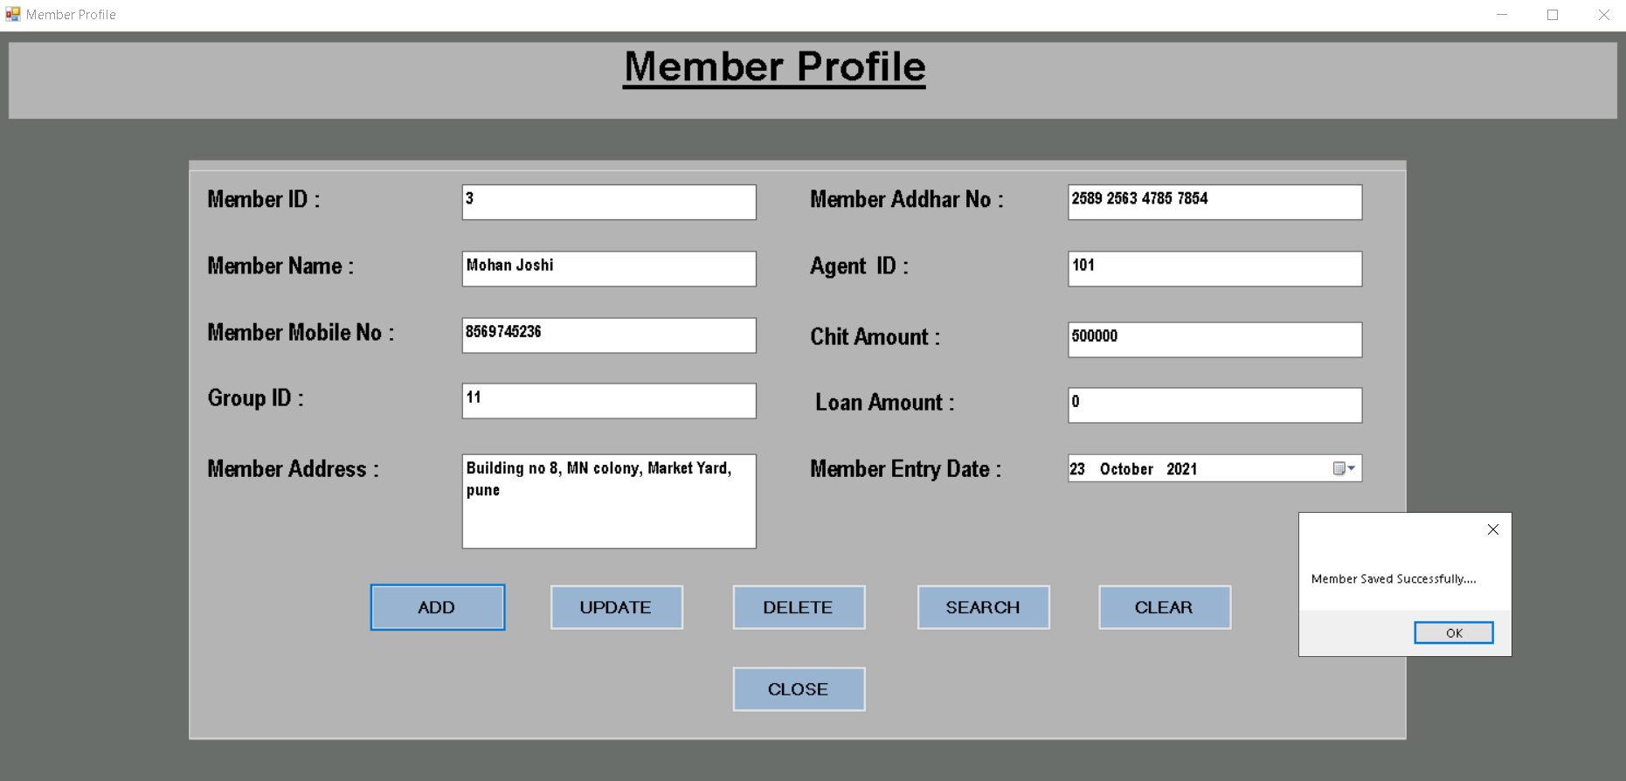

1. **Member Transaction:**

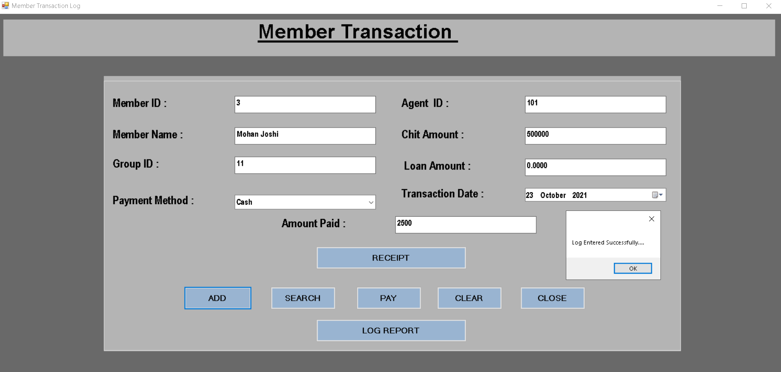

1. **Member Receipt:**

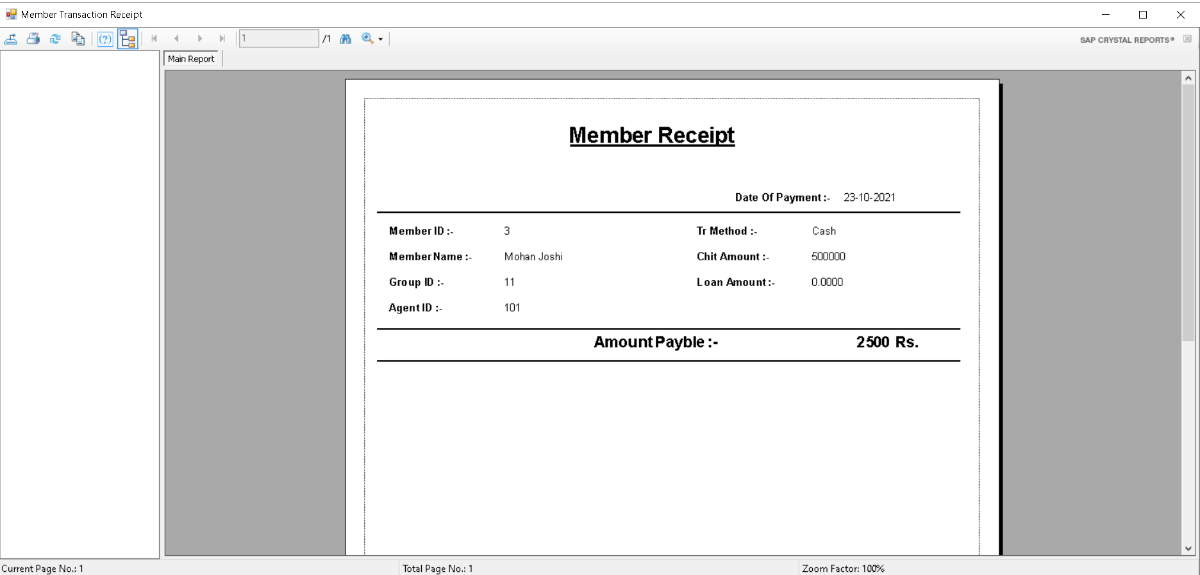

1. **Member Payment:**

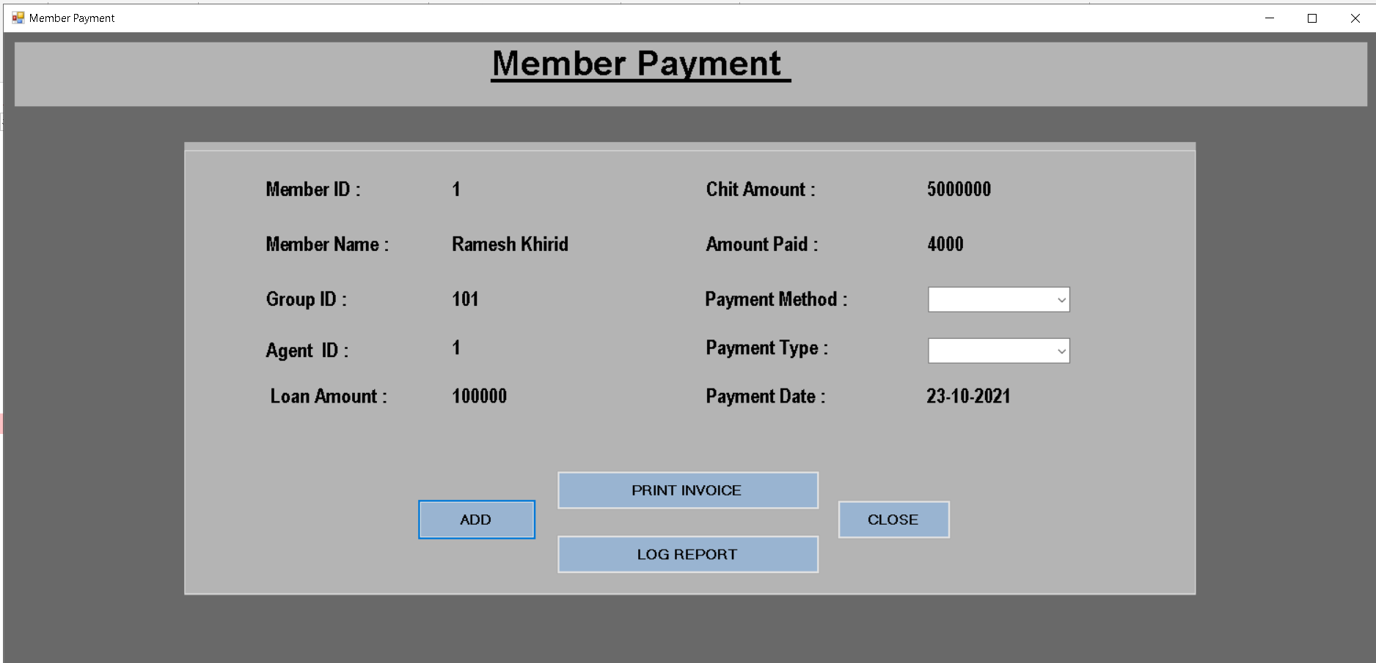

1. **Member Invoice:**

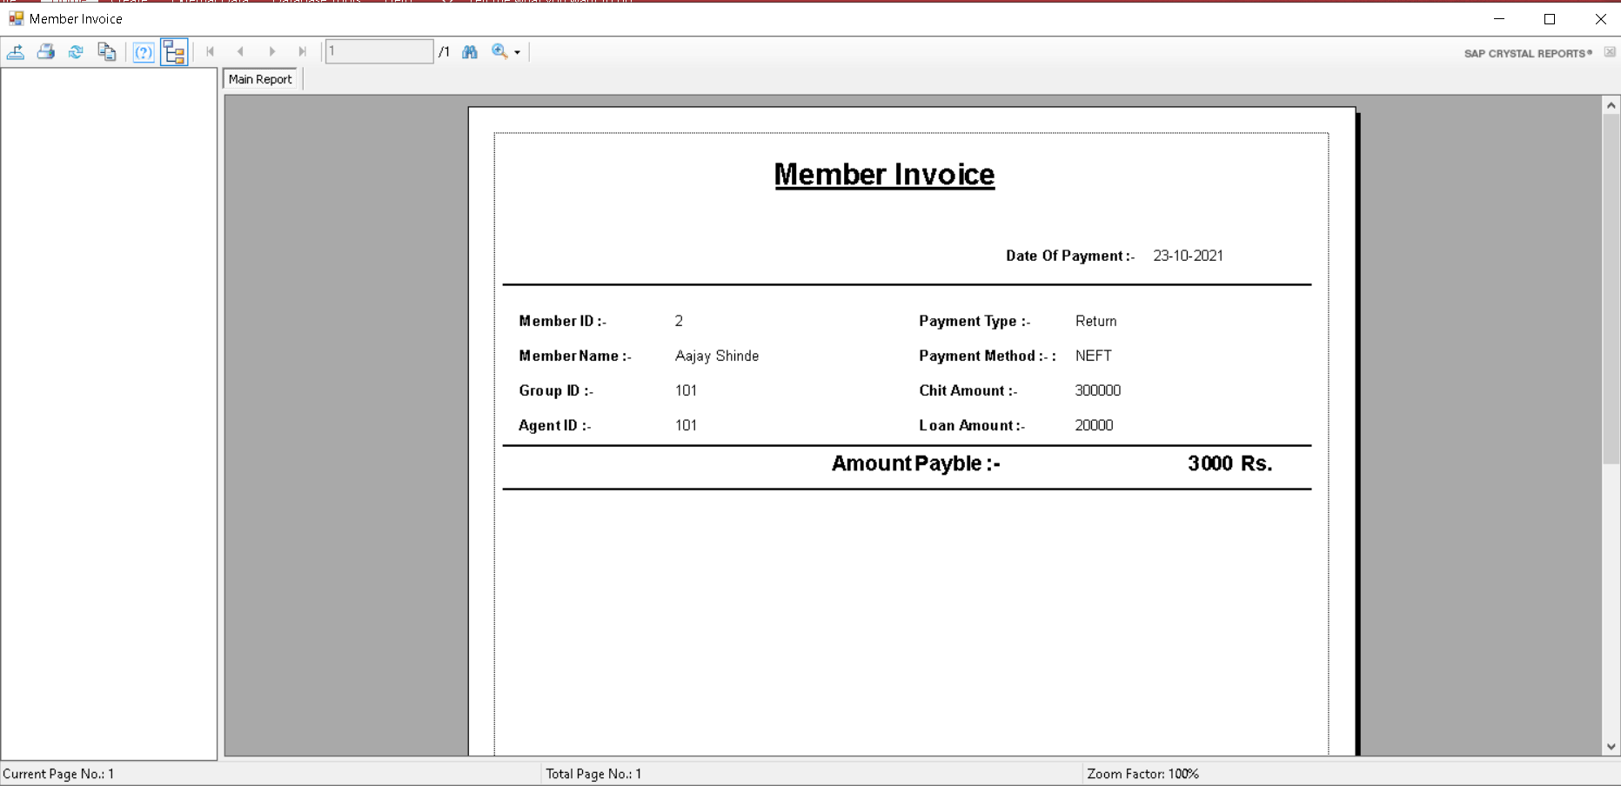

1. **Bidding Process:**

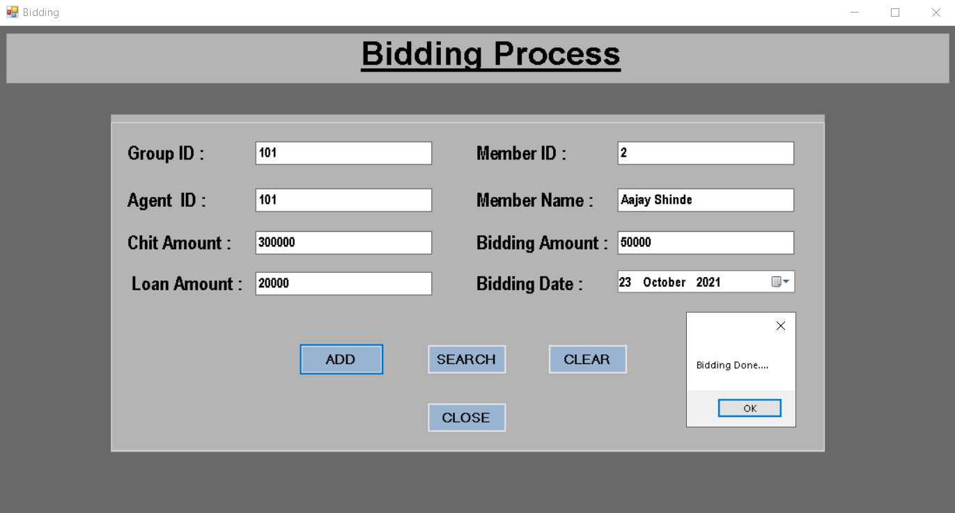

1. **Agent Profile:**

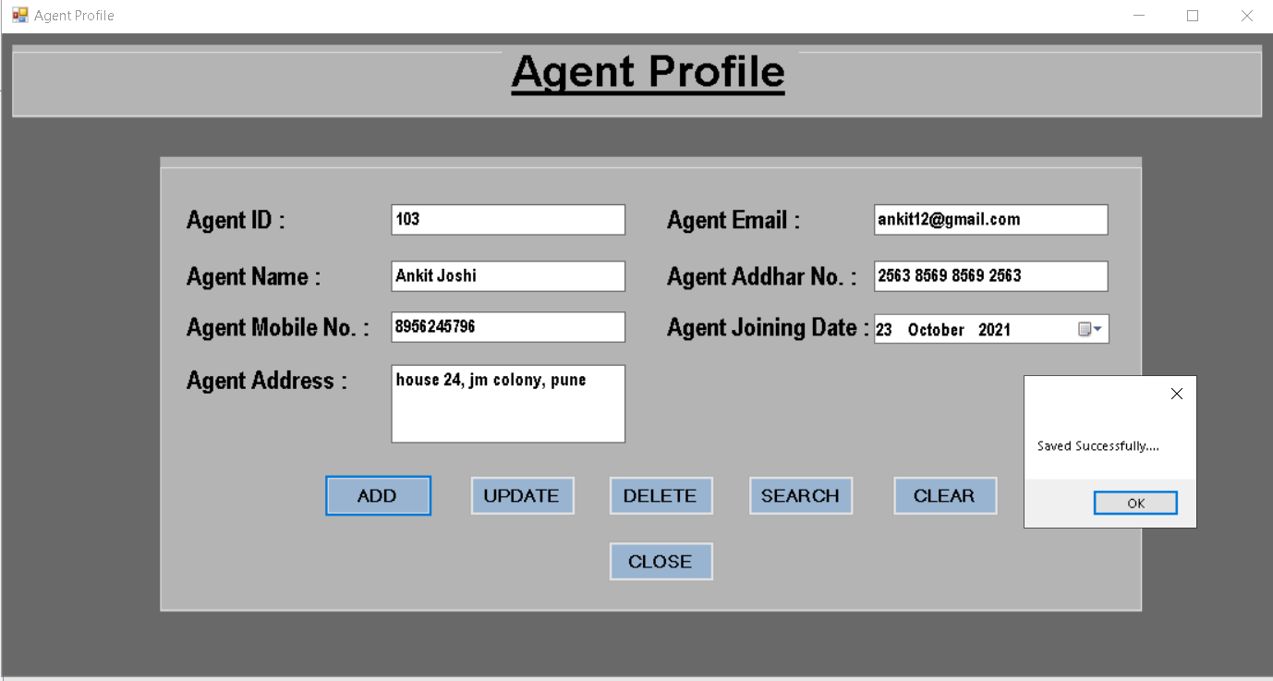

1. **Agent Commission:**

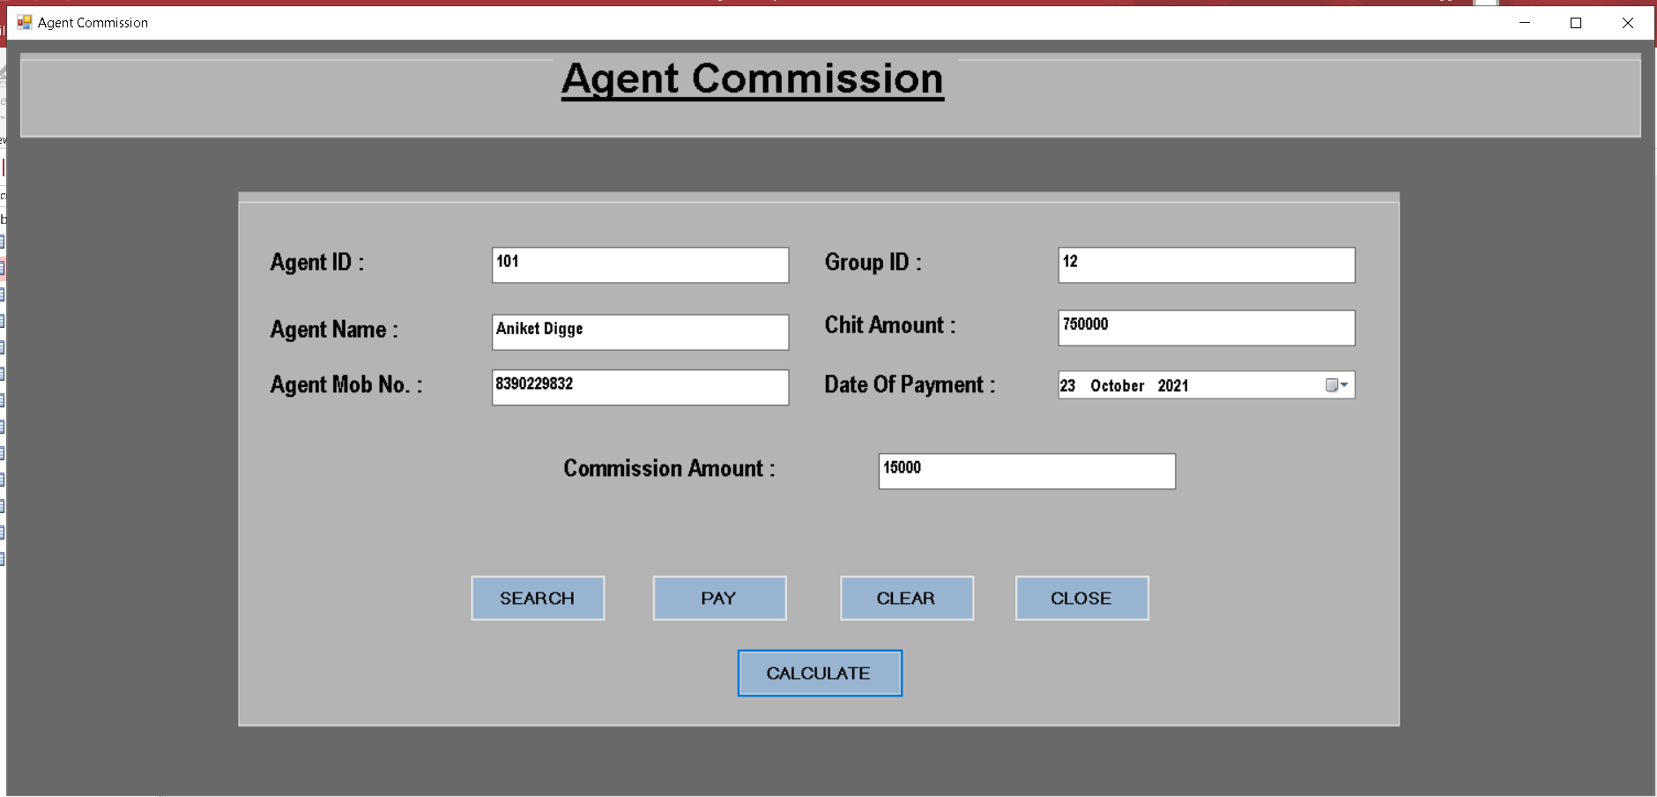

1. **Agent Payment:**

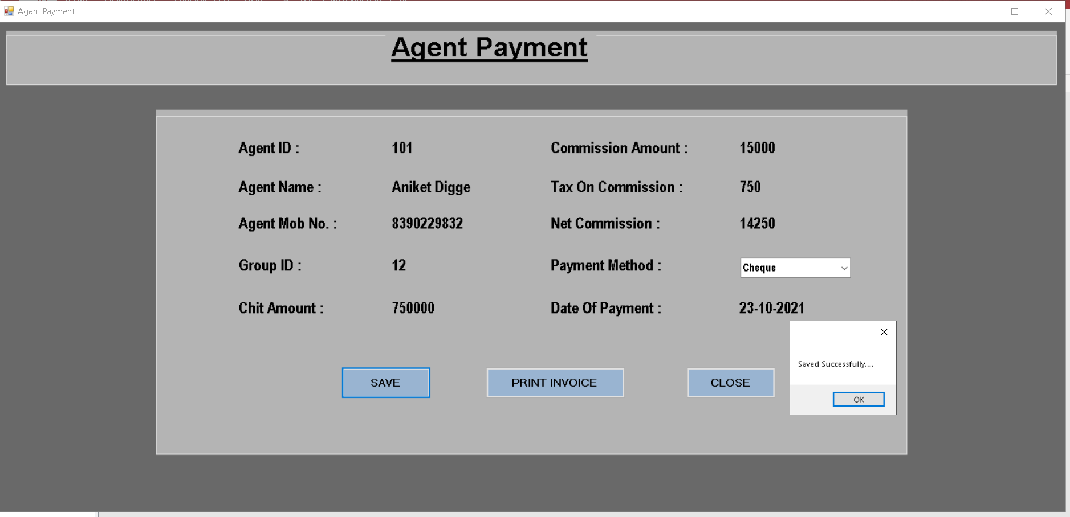

1. **Commission Invoice:**

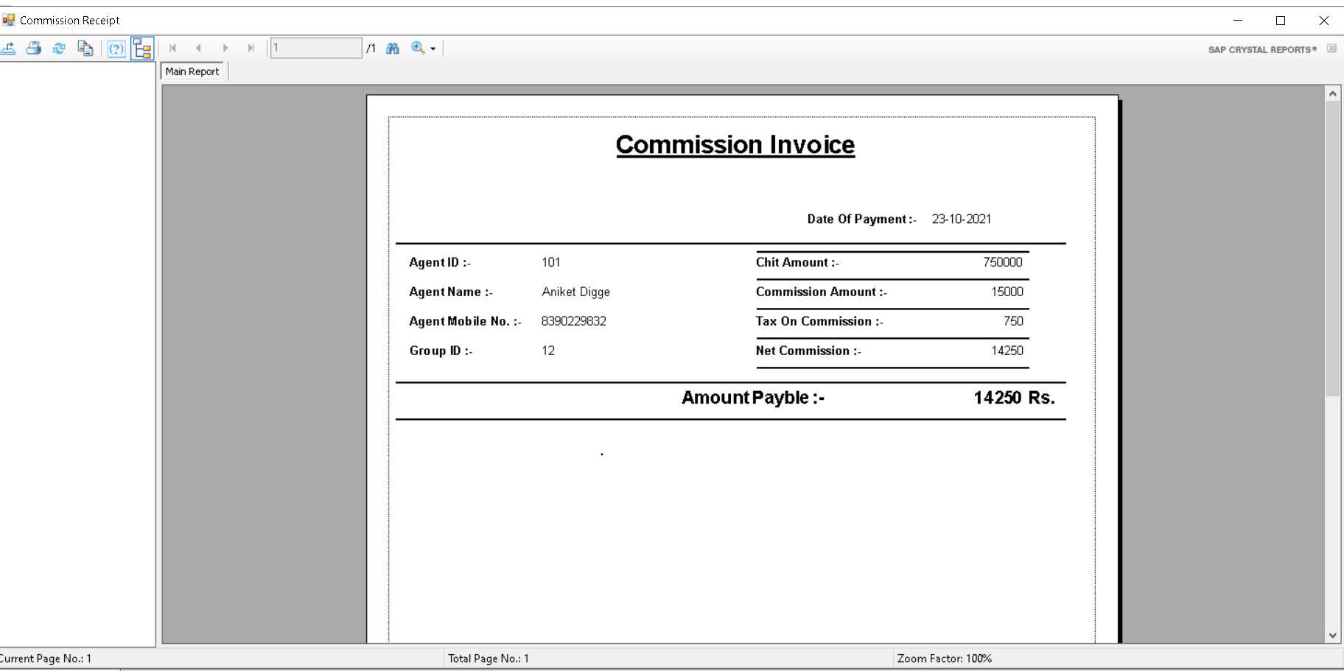

1. **Employee Profile:**

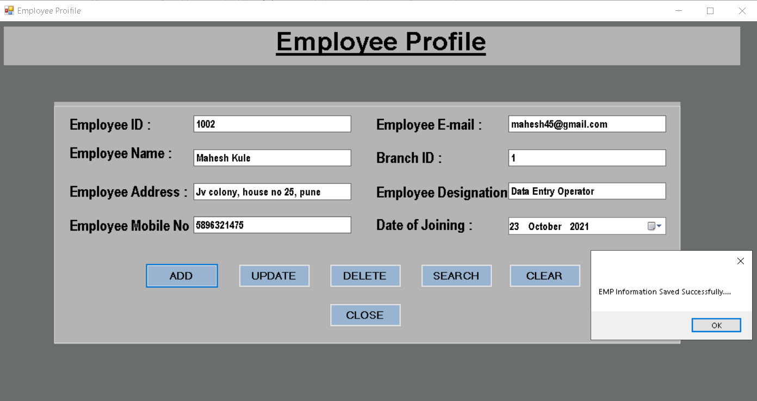

1. **Employee Attendance:**

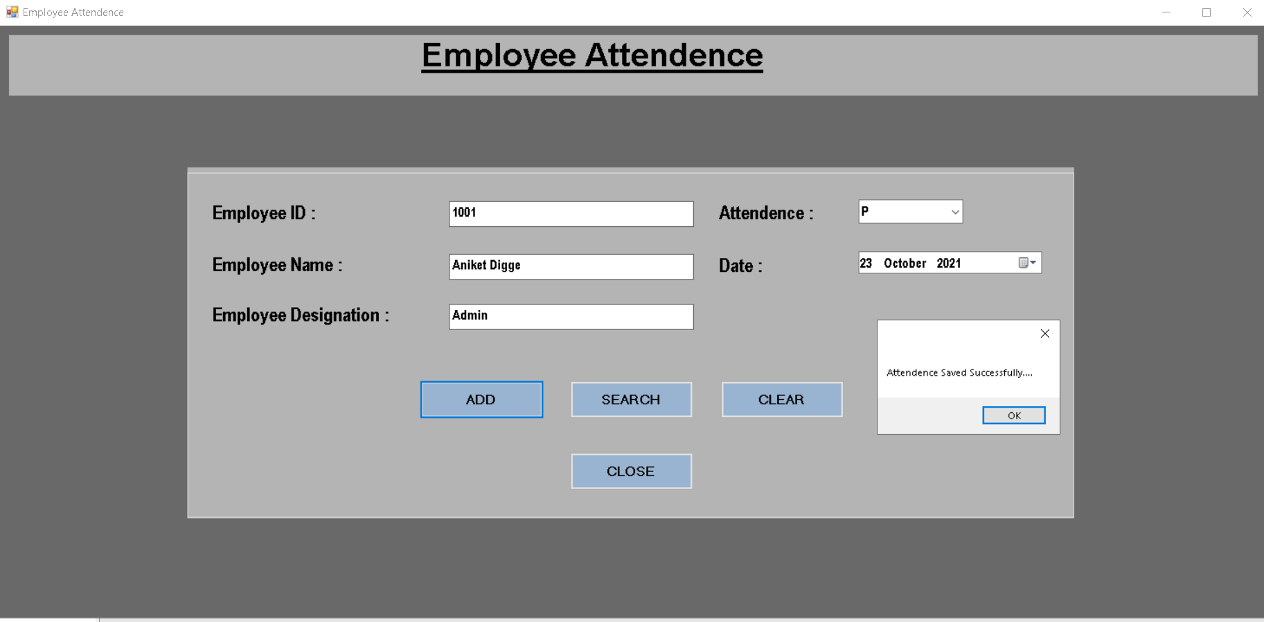

1. **Employee Salary:**

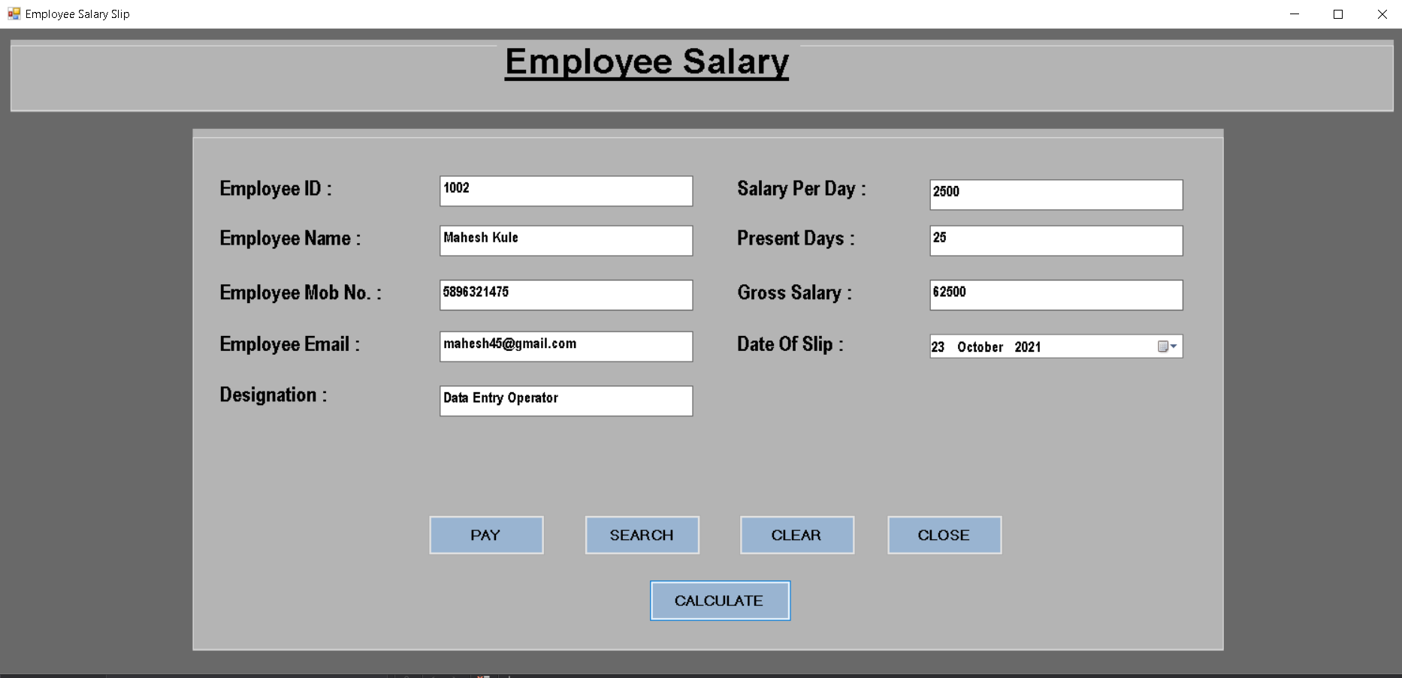

1. **Employee Payment:**

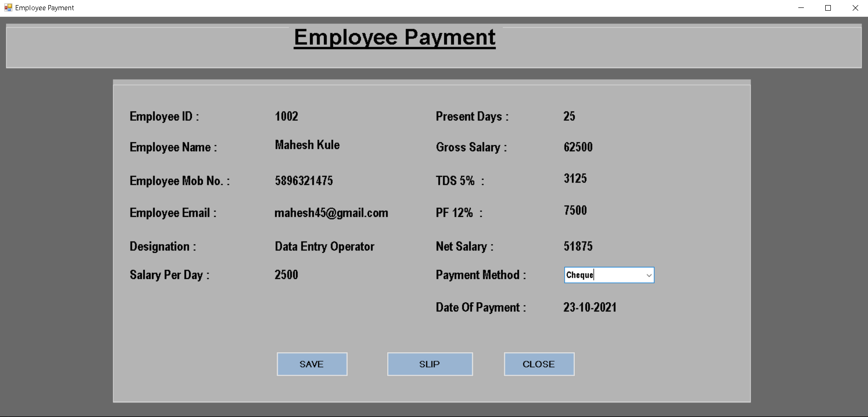

1. **Employee Salary Slip:**

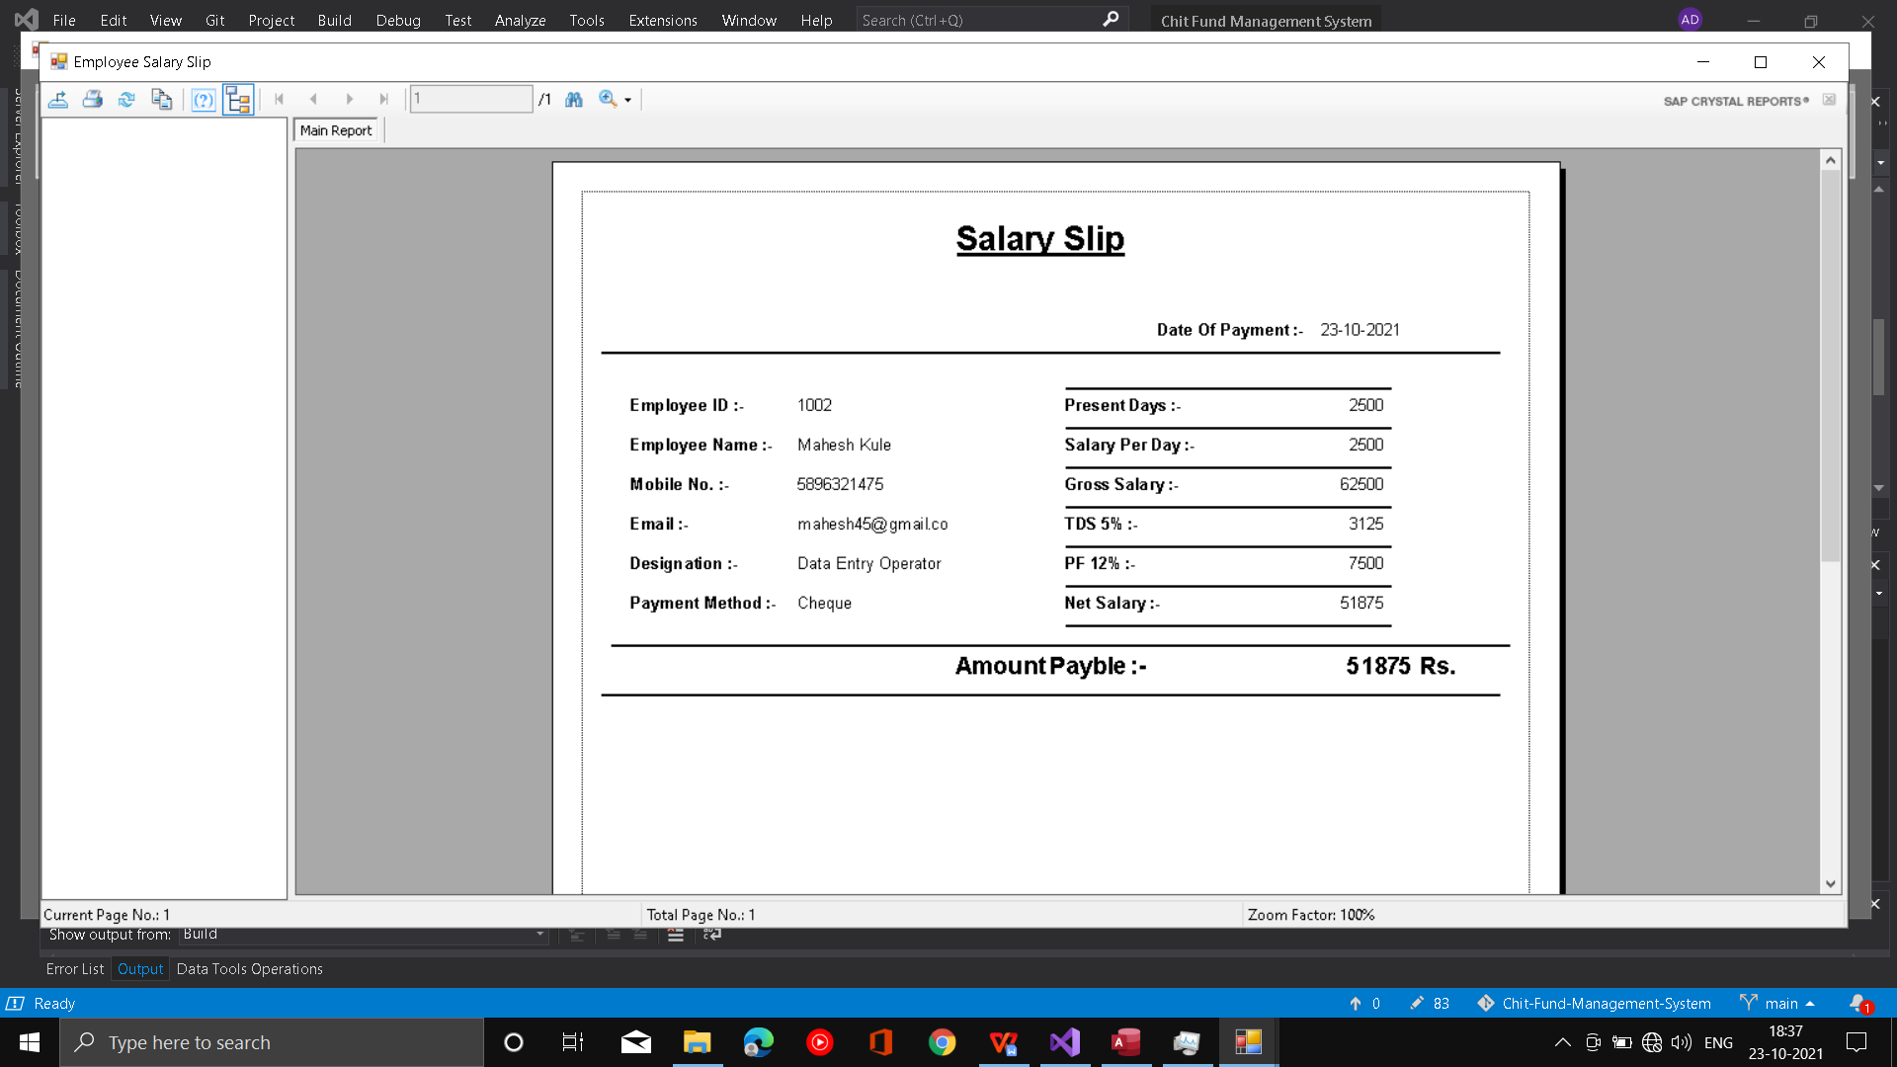

1. **Loan Activity:**

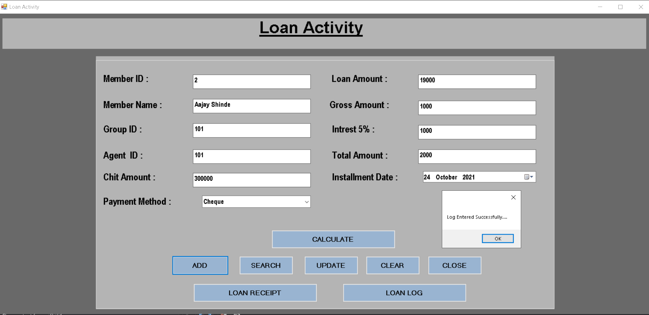

1. **Loan Activity:**

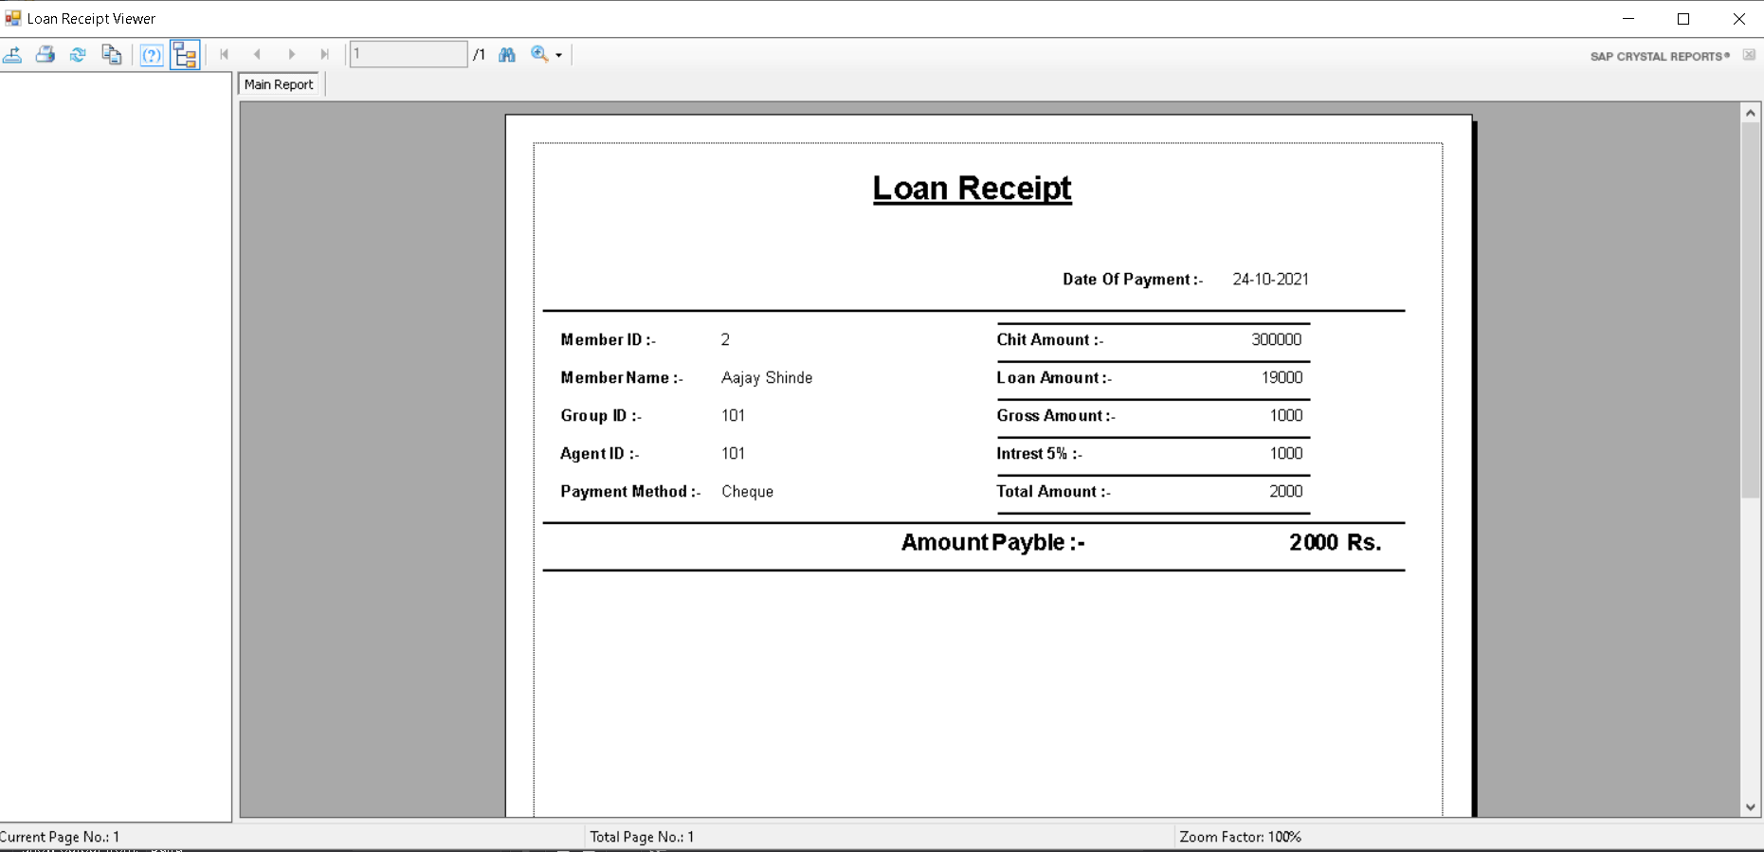

**5.Reports**

1. **Member Transaction Log Report:**

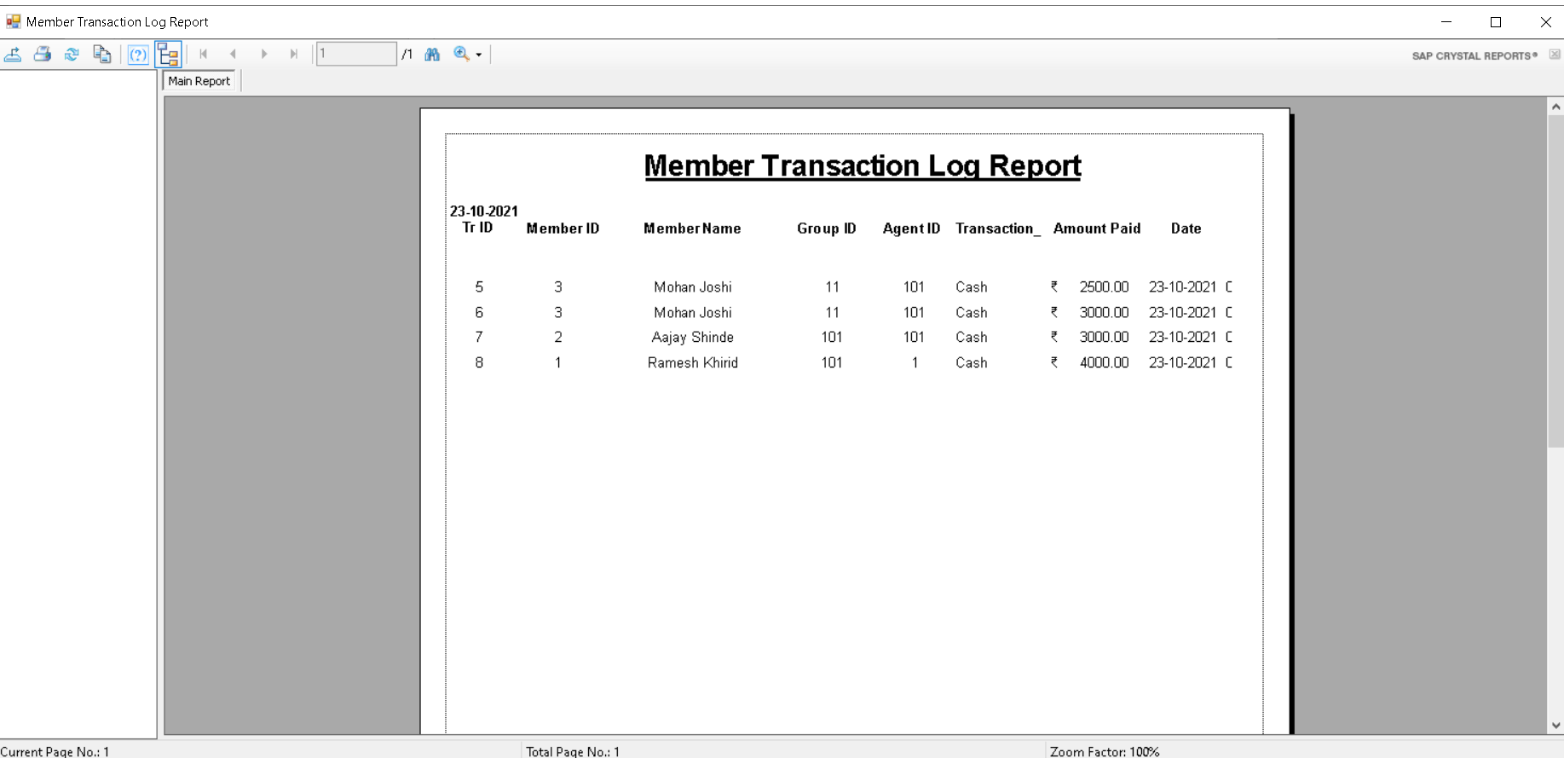

1. **Member Payment Log Report:**

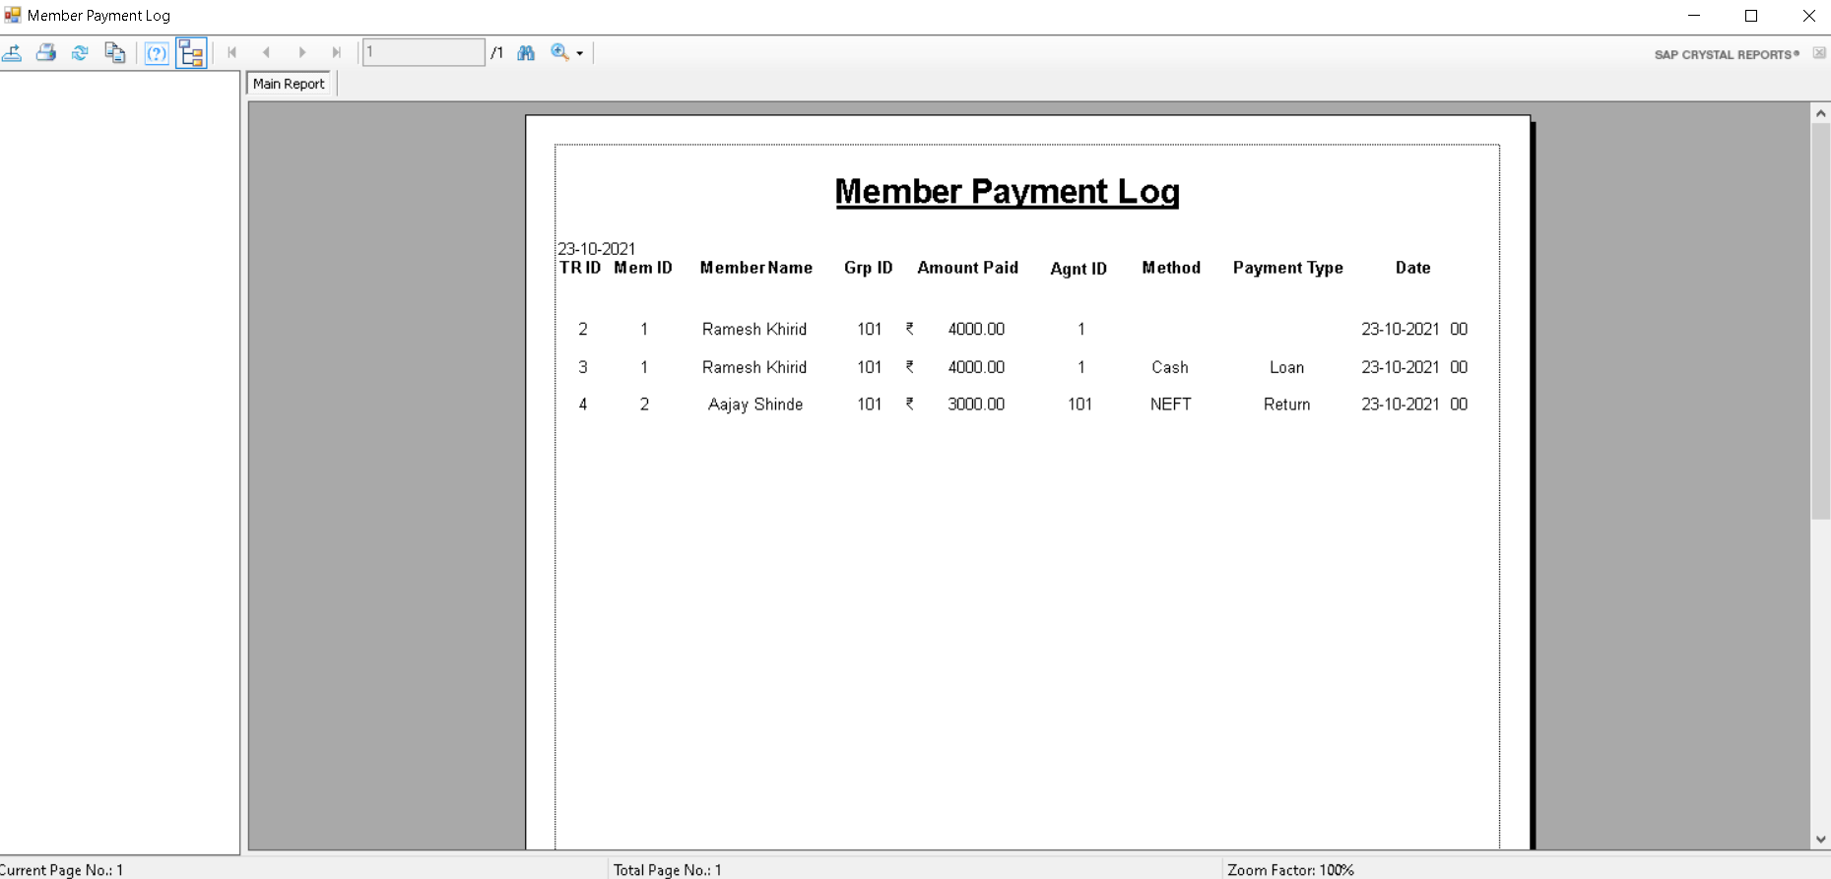

1. **Bidding Log Report:**

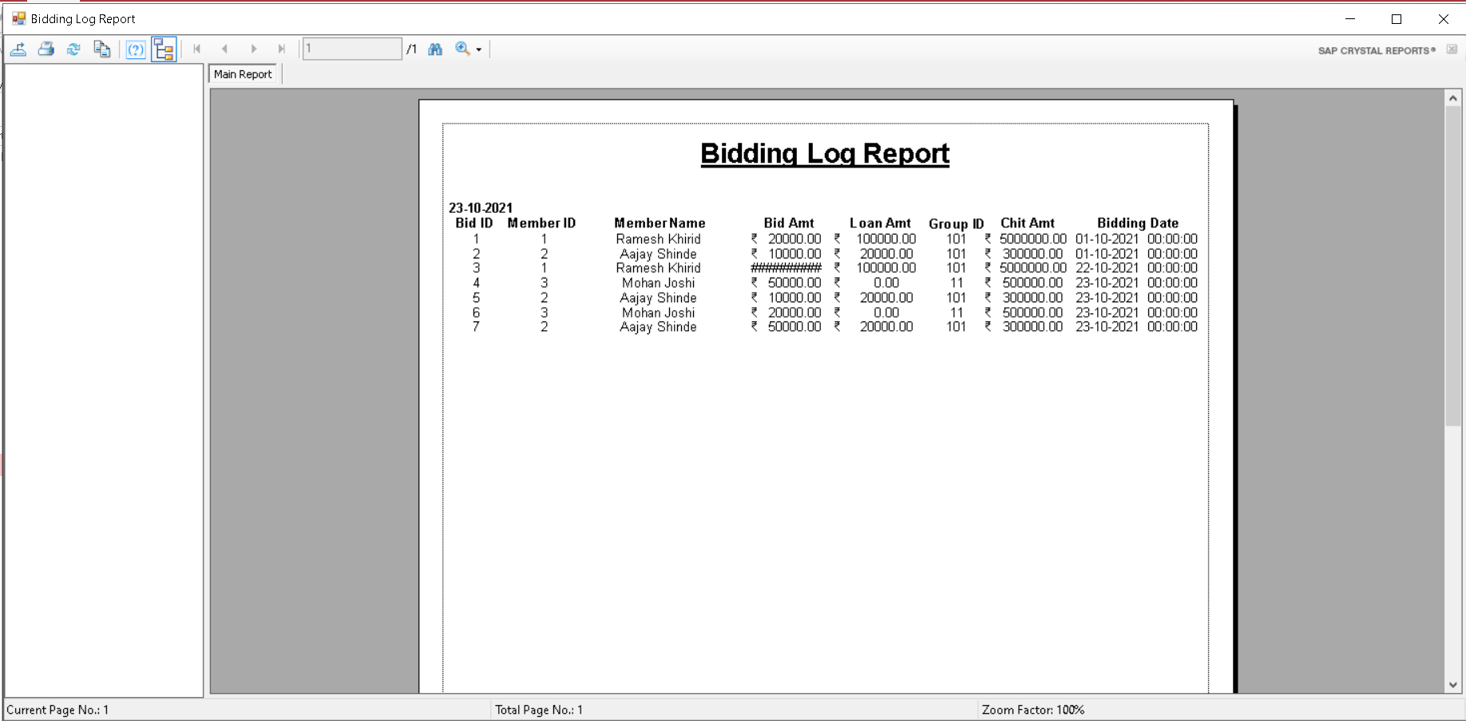

1. **Agent Commission Log Report:**

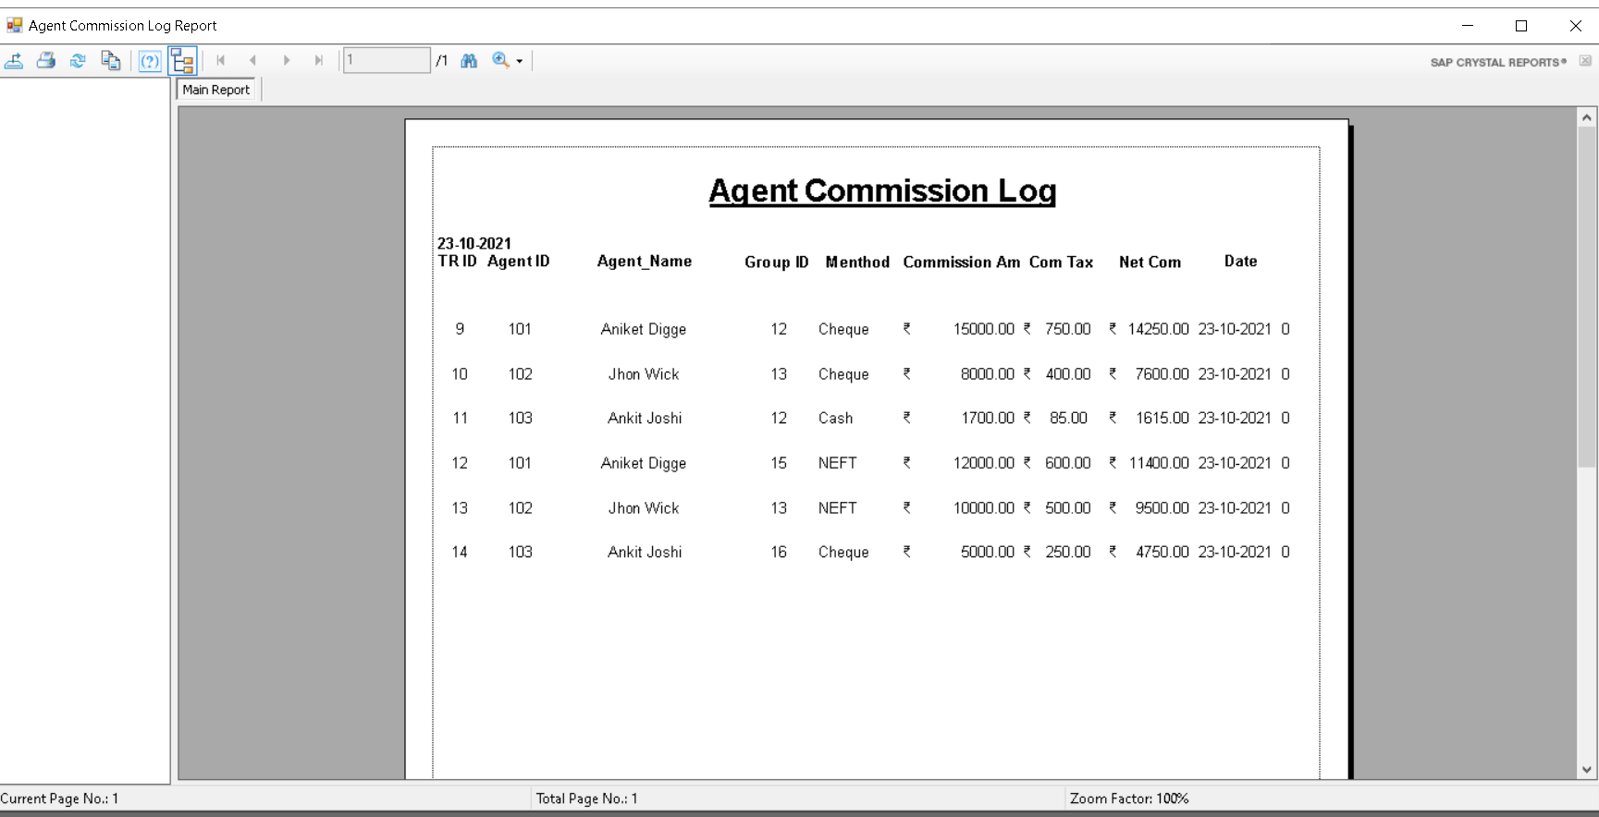

1. **Attendance Log Report:**

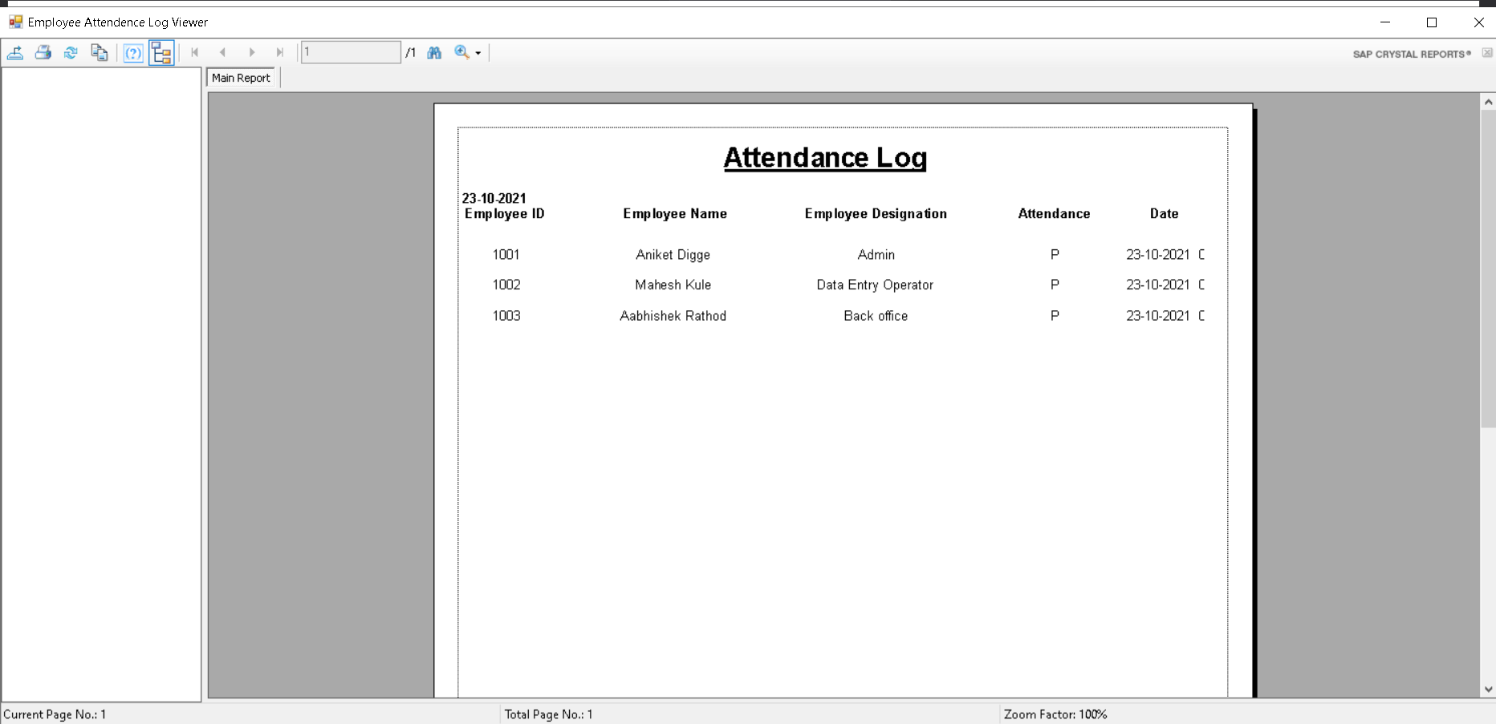

1. **Salary Report:**

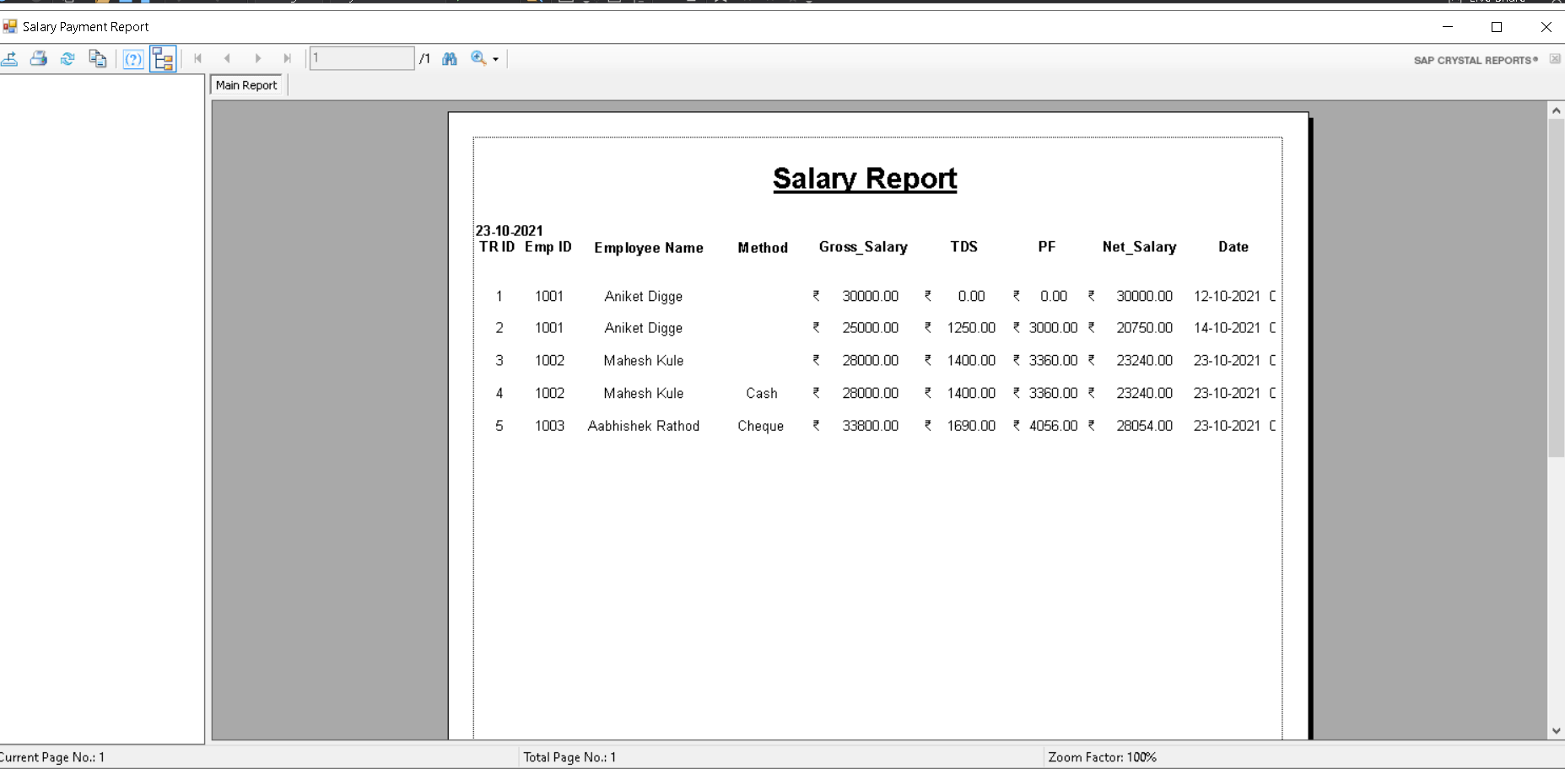

1. **Loan Installment Log:**

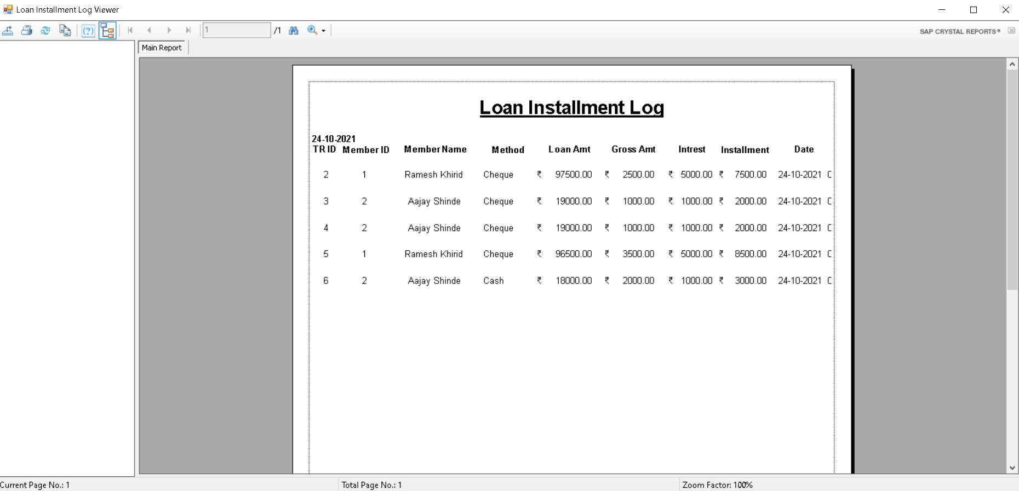

**6.Advantages and Limitations**

**Advantages:**

1. Computerized the current manual system.
2. User friendly interface.
3. Proper authentication is provided to a particular user.
4. Due to login feature security will take place.
5. It is computerized system so it minimize the use of paper.
6. It reduces man power and save time.
7. Reduces human errors.
8. Storage and maintenance of data is easy.

**Limitations:**

1. Proposed system can be handled by only two users.
2. Customer/Member can't interact with system.
3. Online work can't be done by proposed system.
4. Online payment option are not applicable in the proposed system.

**7.Future Enhancement**

Every application has its own merits and demerits. The projects has covered all the requirements. Further requirement and improvement can easily done since the coding is mainly structured for this project. Changing the existing modules or adding new modules can be a improvements. In future the system not only access by admin and employee but also access by member’s and agent’s by that company will required less manpower and less time to do work. Security of system will also enhance by providing appropriate authentication to appropriate user. We would try to add multiple Language as an option for the clients. We also like to add online payment gateway for benefit of the company as well as members.

**8.Bibliography**

**Web Sites:**

1. <https://docs.microsoft.com/en-us/dotnet/csharp/>
2. <https://stackoverflow.com/>
3. <https://www.crystalreports.com/documents/>
4. <https://www.c-sharpcorner.com/>
5. <https://www.codeproject.com/>